British propaganda in World War One
Introduction
During my stay in Agen, France, I worked on a project about propaganda in World War One. The aim of this text is to give an overview of British propaganda in the First World War. It will mention two different types of propaganda, the distribution and some examples for British propaganda.
Distribution of propaganda
When the Great War began, British politicians started seeing the opportunity to help the Allied Forces to win the war by spreading propaganda. In 1914, the Press Bureau and the War Propaganda Bureau were set up, which were responsible for censorship and the production of propaganda. While the existence of the Press Bureau was not a secret, many politicians did not know that the War Propaganda Bureau existed. Famous writers, including Arthur Conan Doyle, were asked to produce propagandistic pamphlets for the government. Because the War Propaganda Bureau was a secret, most people did not know that those pamphlets were produced on behalf of the government.
There were different ways to distribute propaganda. A very important means of spreading propaganda was the propaganda poster. At the beginning of the war, those posters did not feature any images but catchy slogans, for example ‘Your Country Needs You’. Until 1916, many posters urged British men to join the army, but when conscription was implemented, they were not necessary anymore. Therefore, instead of publishing recruitment posters, war bonds or calls for saving food were advertised.
When the Germans started showing anti-British propaganda films, the Britons recognised the value of propaganda films and started spreading some themselves. Five cinema vans were used to show films such as ‘With the Royal Flying Corps in France’ and travelled through Great Britain. Since the British government was afraid that films which showed real battles could be of value to the enemies, they preferred reconstructions. A very famous British propaganda film was the film ‘The Battle of the Somme’, which mostly showed original footage, but also some reconstructed scenes. However, the audiences thought that the whole film had been filmed at the front.
Because fewer people were interested in ‘normal’ books at the beginning of the war, many authors began to write propagandistic pamphlets, which were well paid. The government did not want people to know that authors were employed to write propaganda, so the pamphlets were printed in private publishing houses. Propaganda was also printed in magazines and newspapers or, in the form of leaflets, dropped onto the battlefields with balloons. Those leaflets were to demoralise the hostile soldiers on the battlefields.
Atrocity propaganda
Atrocity propaganda was used to spread enemy’s crimes so that committing it could be justified and people would support the nation to bring the enemy down. Differences between the nations were emphasised and stereotypes were heavily used to spread the hatred against the enemy.
When the British ocean liner “RMS Lusitania” carrying nearly 2000 passengers was sunk by a German U-boat in a war zone off the Irish coast, this created a stir. The ship was later depicted in propaganda posters and used for propagandistic purposes by both the Central Powers and the Allied Powers. A German satire artist created a medallion blaming the British government for the death of the passengers. However, he accidentally got the date of the sinking wrong. British propagandists exploited this mistake and produced copies of the medallions themselves, spreading them and hiding the satirical meaning. This made it seem as though the German government approved of the sinking of the ship and therefore of the death of the passengers damaging Germany’s reputation abroad.
An important piece of atrocity propaganda was the ‘Report of the Committee on Alleged German Outrages’, also called ‘Bryce report’. After the invasion of Belgium by the Germans in 1914, the government formed a committee, chaired by James Bryce, which created a report on the crimes the Germans had committed in Belgium. The statements of eyewitnesses and excerpts from German diaries were put together in the report, which consisted of about 360 pages and described the German’s atrocities in detail. Although the statements were not necessarily true, most people did not criticise the report, as the chairman James Bryce had a very good reputation. The report was spread in a lot of countries and, again, damaged Germany’s reputation abroad. However, when the war was over, the report was discredited and said to be solely the product of British propaganda. This also had the effect that when stories about the abuse of Jews in Germany were distributed at the beginning of the Second World War they were disregarded as lies spread by propagandists.
Patriotic and nationalistic propaganda
While patriotism means devotion and support for a certain place, nationalism is an extreme form of patriotism which includes a feeling of superiority over other countries (Oxford English Dictionary). The aim of patriotic propaganda was to create a feeling of community so that people were willing to defend and support the community. Patriotic or nationalistic propaganda often depicted important national symbols such as flags. In Britain, two of the patriotic symbols which were used were the goddess Britannia (similar to France’s personification Marianne) and the fictional character John Bull, which both personified Great Britain. Other symbols included the British bulldog or Saint George, the patron saint of England. Not only literature, posters and films were used for spreading patriotic or nationalistic propaganda, but additionally, patriotic meetings and lectures were organised to reach a wider audience.
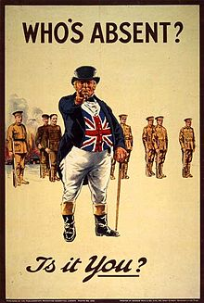
Propaganda poster depicting John Bull (1915)
Source: https://en.wikipedia.org/wiki/John_Bull
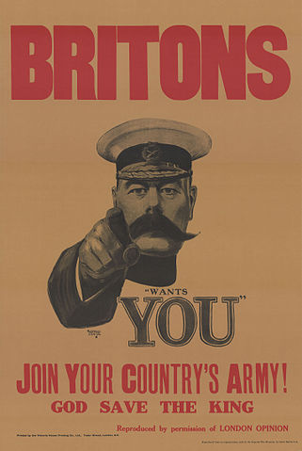
Recruitment poster “Britons: [Lord Kitchener] Wants You. Join Your Country’s Army!”
Source: https://en.wikipedia.org/wiki/Lord_Kitchener_Wants_You (accessed 20/06/16)
Sources:
Sanders, Michael/Taylor, Philip M.: British Propaganda during the First World War, 1914-18. London: Macmillan 1982
Buitenhuis, Peter: The Great War of Words. London: The University of British Columbia Press 1989
Messinger, Gary S.: British propaganda and the state in the First World War. Manchester: Manchester University Press 1992
Welch, David: Propaganda: Power and Persuasion. London: The British Library 2013
Ryley, Jameson: The Historian Who Sold Out: James Bryce and the Bryce Report. In: Iowa Historical Review, vol. 1, no. 2, 2008
www.bl.uk/world-war-one/
https://www.welt.de/geschichte/article140601419/Wer-schuld-war-am-Untergang-der-Lusitania.html
http://www.iwm.org.uk/history/how-a-german-medallion-became-a-british-propaganda-tool
http://www.greatwar.nl/students/papers/collins/propaganda.html
http://net.lib.byu.edu/estu/wwi/comment/bryce.html
written by Lisa Fürst

