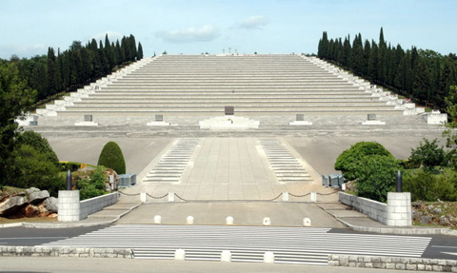

Albert Einstein school  
Cervignano del Friuli  
March 8-9-10 2016

Edoardo BATTAGLIAKristina BUZECANChiara KUHLMANNManon PINCINMarta STIVALAnunska ZELE

Monuments of fallen soldiers

***Monuments of fallen soldiers***

People commonly use the word *memory* as the human capability to keep traces of past experiences in order to recall them whenever they need it. Memory is fundamental for our generations in order to avoid past mistakes and at the same time honoring the fallen of the First World War. Memory is often celebrated with everlasting monuments which represent a past characterized by pain and suffering.

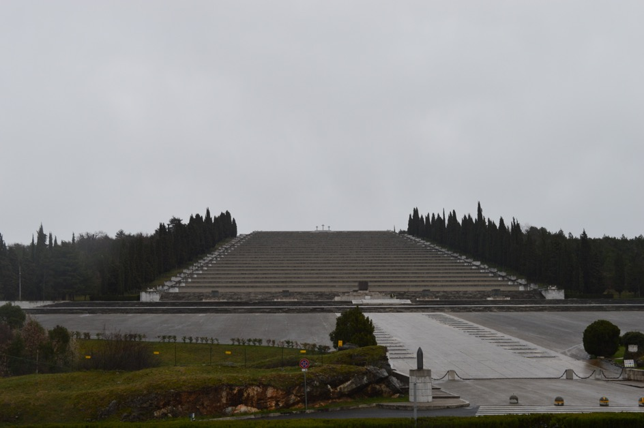

Near the Isonzo river, a well-known battlefield, the most important memorial is **Sacrario di Redipuglia**, also called Sacrario “dei Centomila” which preserves the remains of 100.187 dead soldiers fallen in the nearby areas.

This monument was inaugurated in 1938 and it was strongly wanted by the Fascist Regime. The Regime wanted to honor the sacrifices of soldiers, by representing the continuity between the Great War and the Fascist Regime. It also wanted to give a worthwhile burial to those who didn’t find place in Cimitero degli Invitti (inaugurated in 1923) located in front of Colle sant’Elia.

**Skills: observe and describe – How does the monument appear?**

The structure is made up of three levels and it symbolically represents the Italian army coming from the sky (or ascending it) led by their own chief to cross Via Eroica. On the top, three crosses remind the image of the Calvary hill and the Crucifixion of Jesus Christ.

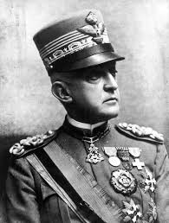In the square there are many majestic graves of generals, among which Emanuele Filiberto Duca d’Aosta ( Genova 1869 – Torino 1931 ) chief of the Third Army, who had expressed the wish to be buried in Redipuglia.

The monument is made up of 22 big steps with the names of the 39857 identified soldiers, organized in alphabetical order. In the middle of the first big step we can see the only woman buried there the Red Cross nurse: Margherita Kaiser Parodi Orlando, while 72 mariners and 56 soldiers of Guardia di Finanza are buried in the 22nd  step.

On the top of the monument, two big graves shelter the remains of over 60.000 unknown soldiers.

The monument was designed by the architects Giannino Castiglioni and Giovanni Greppi and was inaugurated in 1938.



**Skills: deduct or decode – What does the word “Presente” mean on each step?**

The word “presente” recalls a kind of performance made in order to honor the dead soldier when someone called his name and the crowd answered “I am here!” after a Fascist Ritual.

**Skills: analyze and interpret – What does the linear and symmetrical design represent?**

The monument is intentionally deprived of any decorative element to convey the sacred message that death makes people equal. If Sant’Elia cemetery impressed the veteran with vivid memories of the battlefield, now the Mussolini-like mausoleum responds to the Fascist aesthetic code. The monument recalls the model of the State and society of the Fascist Regime.

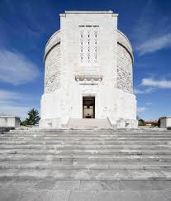***The monument of Oslavia***

The monument was based on the project of Ghino Venturini and built in 1938. The shape is made up of a central cylindrical tower on the top of a big ladder. There lay the remains of 57.741 soldiers ( 36.000 unknown ) died in the area near Gorizia. The buried soldiers are mainly Italian, with the exception of 540 Austrian soldiers.

Before the military monument was built, some remains were in “Cimitero dei Quattro generali” in Oslavia.

Every evening the strokes of the bell can be heard in memory of all dead soldiers of all wars and every 8th August (anniversary of the liberation of Gorizia, 1916, during the sixth Isonzo battle) a ceremony is held in honor of the fallen soldiers.

**Skills: analyze and interpret – Why such a shape was chosen?**

The monument is made up of a big central tower and three smaller lateral ones.

Oslavia monument is very sober according to a repetitive architectural style sometimes following a hierarchical principle. Differently from Redipuglia, which occupies a huge area, Oslavia monument conveys a different message: a cemetery, which looks like a fortress dominating the eastern newly annexed Italian territories.

**Skills: argue – What was the Fascist ideology which led to the building of such monuments?**

Fascist regime changed the way in which memory and heroic values were transmitted since their main goal was to shape society and its institutions. Consequently the “Holy sites of the Nation” became a part of regime rituals. Fascist project implied the building of sacred areas according to a military-print.

All these sacred monuments were built near the eastern border in order to transmit a new sense of patriotism.

***Douaumont Ossuary***

The Douaumont ossuary is a peaceful French memorial containing the remains of 130.000 soldiers both German and French who died on the battlefield during the [Battle of Verdun](https://en.wikipedia.org/wiki/Battle_of_Verdun) in [World War I](https://en.wikipedia.org/wiki/World_War_I). It is located in Fleury-devant-[Douaumont](https://en.wikipedia.org/wiki/Douaumont), Meuse, in [France](https://en.wikipedia.org/wiki/France), within the [Verdun](https://en.wikipedia.org/wiki/Verdun) battlefield. The first stone was laid in 1920 by Maréchal Pétain, the « winner of Verdun ».

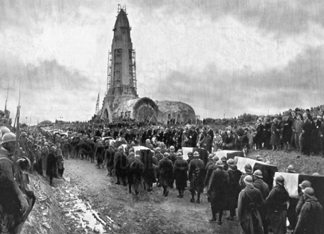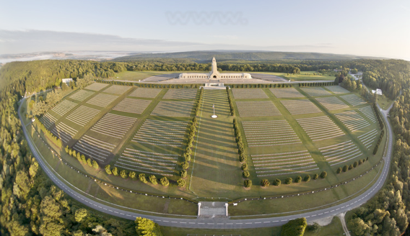

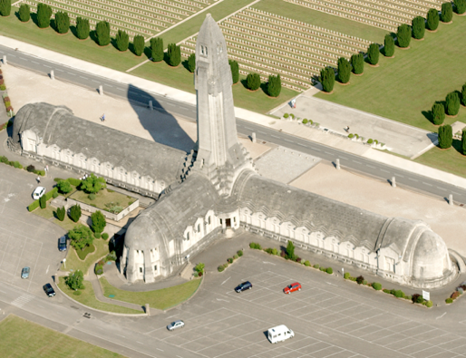

**What is the crowd doing? What is the symbolic of their action?**

They bring back soldiers’ bones from the battlefield of Verdun. This is a strong reflection of the importance for people’s mourning to collect all this bones and perpetrate memory.

**What makes you think the ossuary’s figure?**

A sword of a fighter, pushed into the ground. Moreover, the tower has a form of bombshell.

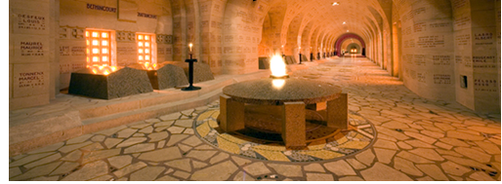The cloister is 137 meters long, with graves which represent the different geographic zones of the battle of Verdun and the shield where the flame of the memory burns. Each stone represents a

diseased soldier’s name. The tower,

which is also named “The lantern of the

dead”, is 46 meters high and brightens

on a panoramic view of the battlefield.

The flame of the memory

We need to climb 204 steps to reach

the headlight. Outside, the “nécropole nationale” is set on the old battlefield.

This site has a double meaning: moral and historical. By the historical point of view, Douaumont was especially known for his fort. But it also has an emotional meaning and strong images almost as the main entrance to history. This sacred site may makes you feel you uneasy as if you couldn’t breathe since you realize what war really means, especially when you read the name of the soldiers inside but also when you see the huge number of graves outside. The cloister always lighted consolidated the glory made to all those who died not only in Douaumont but also in Verdun battlefields.

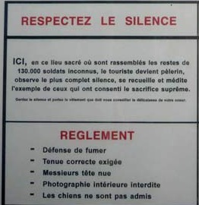

**Ossuary rules**

Here, in this sacred place where are gathered bones of 130.000 unknown soldiers, the tourist become pilgrim, remain absolutely quiet, mediate example of those who have agreed supreme sacrifice.

-No smoking

-Correct outfit required

-Naked head gentlemen

-No photography inside

-Dogs are allowed

We can notice that the rules are very strict and codified. It shows us well that before tourism, Douaumont is a sacred place of memory where standards and formal rules need to be respected.

***Memorials for the lost ones in Germany***

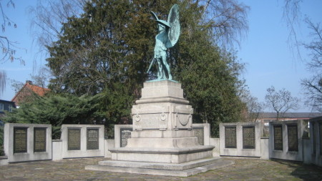In Germany, there are no big and heroic monuments because Germany lost the war. The defeat was not celebrated, but the lost ones were honored with smaller monuments. Many cities have monuments of their own to honor their lost soldiers. An example for this can be found in Senden, a small town near Münster in North-Rhine Westphalia.

**The monument with the rolls of honor in the back**

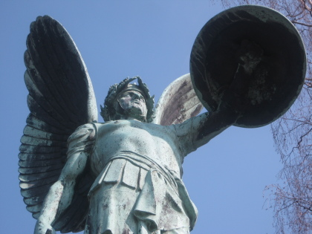

**The statue**

**Skills: Observe and describe** - **Describe the statue on the base. How did the sculptor shape it? And what message does he want to convey?**

**Skills: deduct and decode - What do you think about the monument considering the fact that Germany lost the war?**

**Skills: Analyzed and Interpret - Think about the intention of the people who added the names of the lost ones from WWI later*.* Can** **you imagine why they placed them right behind the old monument?**

The monument was erected in 1909 by the sculptor Wilhelm Haverkamp. It is in the style of the belle époque and reminds the observer of antiquity, so it is not a modern way to build a monument to remember the soldiers. The rolls of honor for the soldiers lost in World War I were added later, so initially it is not a memorial for the WWI.

The bronze statue is meant to represent archangel Michael, who is the patron saint of Germany. He is wearing a helmet, holding a sword and a shield and he is seen as self-confident and heroic in a victorious position. The base is in the shape of a sarcophagus. Archangel Michael is also called the “conqueror of the devil”, so it does not really fit in with the fact that Germany lost the war.

Originally the monument was erected to honor the lost ones from Senden, who died in the Napoleonic wars 1792-1815, in the German war of 1866 and in the Franco-Prussian war in 1870/71. The 16 rolls of honor around it with the names of the lost ones from World War I and II were added in 1958 by the local shooting club.

Now the question comes up why they did not build a new monument, to remember the war appropriately.

***Throne of Boroevic***

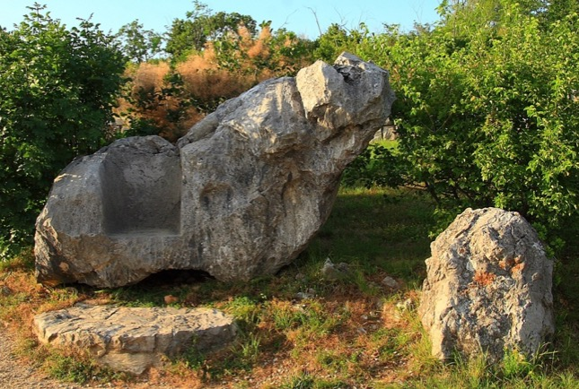Boroevic was in command of the Sixth Corps on the Eastern front when the First World War began. Soon he leaves the Eastern front and he became the commander of the Fifth Army, with which he organized defense against Italians. He was advised not to defend the better part of today’s Slovenia. He insisted that Slovenians will defend their land and he fought with thirty of his detachments. Because of that he was given command on The Soca River (Isonzo).

The 43rd Infantry Regiment built his monument. This is also carved in stone on the back (ERBAUT VOM K.u.K. IR 43). On the right side of the monument it is carved the surname Pristan, who is probably a person that made it. It also had a function of signpost, because it gives the distance to Lokvica and Kostanjevica.

**Skills: Observe and describe – Deduct and decode**

Describe the outfit of the sculpture.

Why do you think that this monument is so simple?

Why is this monument so important for Slovenians?

***Log Pod Mangartom***

**Skills: Observe and describe – Analyze and Interpret**

What is in the picture? Describe it.

Why do sculptured soldiers look up?

Do you prefer simpler monuments like the previous one (Throne of Boroevic) or more complicated ones like this statue?

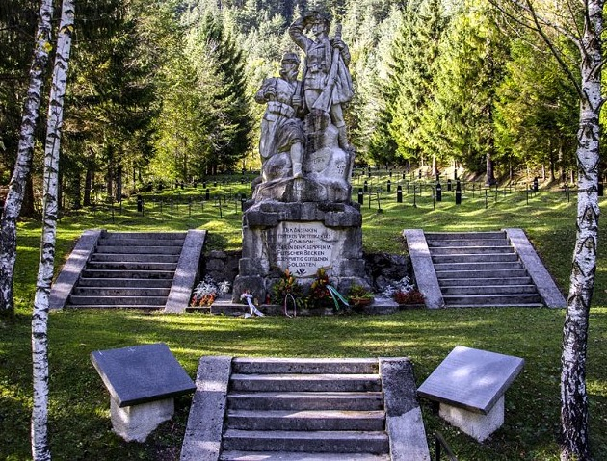In this Cemetery are buried more than 800 Austro-Hungarian soldiers in the four terraces (depending on the date they died). Graves of soldiers were marked with crosses; Muslim graves were marked with notches (typical Muslim tombstone). In front of the Cemetery is a monument to the fallen soldiers, created by Czech sculptor Ladislav Korfanek. It is dedicated to the killed defenders of Mt. Rombon. Sculpture shows one Bosnian soldier and one Austro-Hungarian who look up towards the top of the mountain, where the majority soldiers died in fierce battles (and are buried here).

***Solkan***

**Skills: Observe and describe – Analyze and Interpret**

Describe the picture? Do you see anything unusual? If yes, what?

Why is the cemetery not completely in original layout?

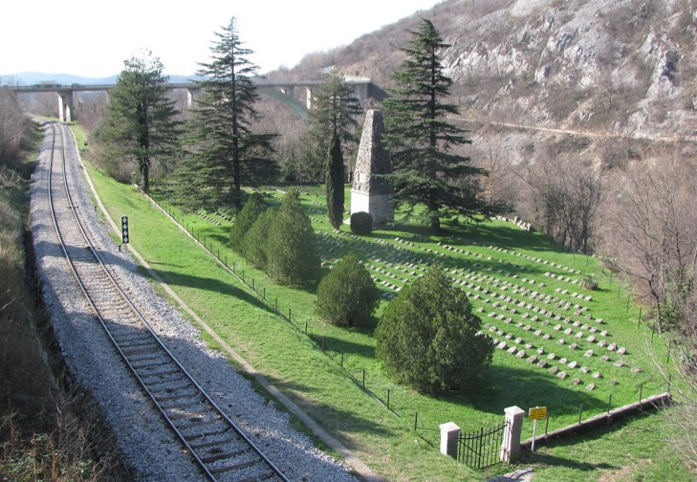Do you think that nowadays the access is difficult and risky? If yes why?

The Austro-Hungarian military cemetery is found on the left bank of the Soča river (Isonzo), just by the railway between Solkan and the railway bridge across the Soča (Isonzo). In this cemetery are buried the Austro-Hungarian soldiers (mostly Hungerians), who fell on the Gorizia bridgehead during the sixth battle of Isonzo (August 1916). In original cemetery is the 16th species distributed throughout the 85 headstones, together there were about 1360 graves. The nowadays layout is mostly the same as it used to be, except the extreme edge of the inclination towards the Soča. This edge collapsed during bombing in Second World War and it was later renovated. It is said that there were around 5.100 people buried in original cemetery. In the 1930s the original cemetery was enlarged, because a lot of mortal remains of Austro-Hungarian soldiers were transferred to it from abandoned Italian cemeteries. In the middle of this cemetery is also a monument (high about 12 meters) which was completed with a high truncate pyramid, built of rough stone.