10/03/2016
Pozzetto Alessandro - Tassile Federica - Pasquet Lola - Wiesker Celina - Maruska Slavec- Naja Skrlj
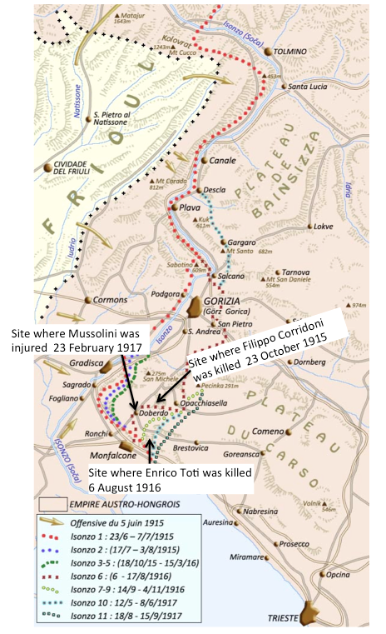

Progetto Erasmus | THE HERO FACTORY

Enrico Toti’s biography

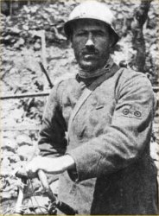
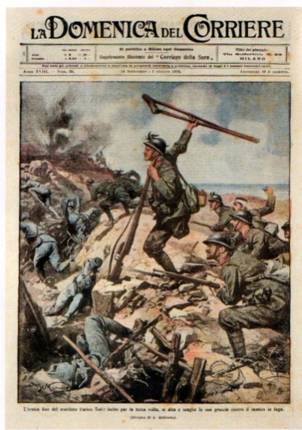
Born in Rome, on 20th August 1882. First he joined the naval school and helped against the pirates in the Red Sea. Later, he joined the State Railways and because of an train accident, they amputated his leg up to his pelvis. He lost his job and began creating small inventions (they are now in Rome). In 1911, he began his cycling journey in Paris, up to Finland and Lapland and returned to Italy through Poland. He wanted to cycle Africa, but did not make it past Sudan due to dangerous circumstances. His recruitment pleas were rejected, so he joined the front in Cervignano as a civil volunteer. The carabineri of Monfalcone sent him home, but he returned thanks to the interest of Duke of Aosta and later became a cyclist bersagliere of the third battalion. In August 1916, the sixth battle of the Isonzo began and concluded with the occupation of Gorizia. On 6th August, Toti and his troop threw themselves at the enemy in a heroic gesture and he screamed: “I will not die!” He was decorated with the highest medal of honor by king Vittorio Emanuelle III in person. He has two submarines and streets named after him, along with two monuments.

1) Skills: analyze and interpret – With the La Domenica Del Corriere’s front page, explain that Toti is seen as a hero.

Skills : Digital skills – Search how can we honor Toti.

Nazario Sauro’s Biography
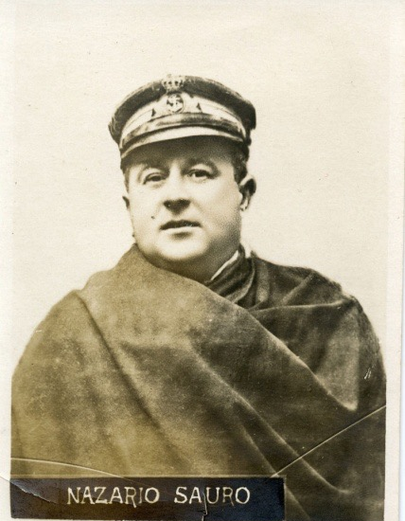
Nazario Sauro (*20.09.1880- +10.08.1916 ) was born in Capodistria (present-day Slovenia) which at the time was part of the Austro-Hungarian empire.He was an Austrian-born Italian irredentist. Nazario finished the school with good grades and his father wanted him to continue studying but his real passion was the sea. He had started sailing at a very young age, and when he turned 20, he was already the captain of a cargo ship.His passion for the sea influenced his later job. After Venice was annexed to Italy irredentism came up. Irredentism is a Italian- nationalist ideology that promoted the reoccupation of the lost territories. Nazario strongly supported this ideology and therefore voluntarily involved himself in the war against Austria even though he was born as an Austrian.Nazario signed up for the Navy and was promoted Sub-Lieutenant in June 1916 and was awarded a silver medal (Italian: Medaglia d'Argento al Valore Militare), which honors courage. He had helped to accomplish sixty military missions.His submarine, of which he was pilot, crashed into a rock on the 30th June 1916 in the Kunvar Gulf and the crew was intercepted by an Austrian destroyer ( military ship).Sauro was imprisoned and put on military trial because of his previous act of treason. After the trial Nazario Sauro was sentenced to death and hanged on the 10th august 1916.

2) Skills: analyze and interpret - Why people considered him a hero?
Why was irredentism important and topical during that period of time?
Why is Nazario Sauro presented as a national hero and by which means?

Skills: digital skills, describe and deduct- Are there monuments dedicated to him? Why ?
Filippo Corridoni’s biography

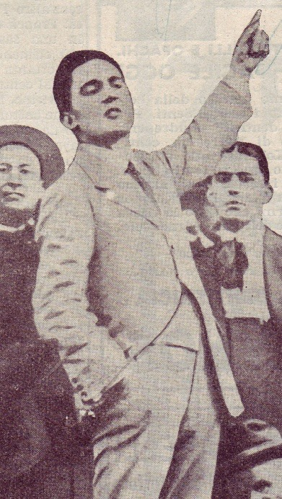
¹ Filippo Corridoni was born in Pausula (Corridonia today in his honor) in the Province of Macerata, on August 19, 1887 and fell in combat on the Carso, the "Trench Frasche", October 23, 1915. He flowed immediately in the social unrest, militating in the ranks of the Revolutionary syndicalism. He thought that the workers' unions may create a state within a state and then proceeded to the conquest of power. He supported stoic firmness in a long series of battles against the employers who also led to persecutions and exiles. He combined the masses idea of revolution with the idea of ​​homeland and national duty; he sided with Mussolini for intervention. He also volunteered to be first line soldier.He often returned after difficult missions, repeating his usual phrase: "We must win at any cost. The enemy must be crushed."
On October 23, 1915 he moves to the assault of the Trench Frasche where he falls mortally wounded.He was decorated with a silver medal, which turned later into a gold medal at the memory.
3) Skills: analyze and interpret - Why people considered him a hero by using this biography ?

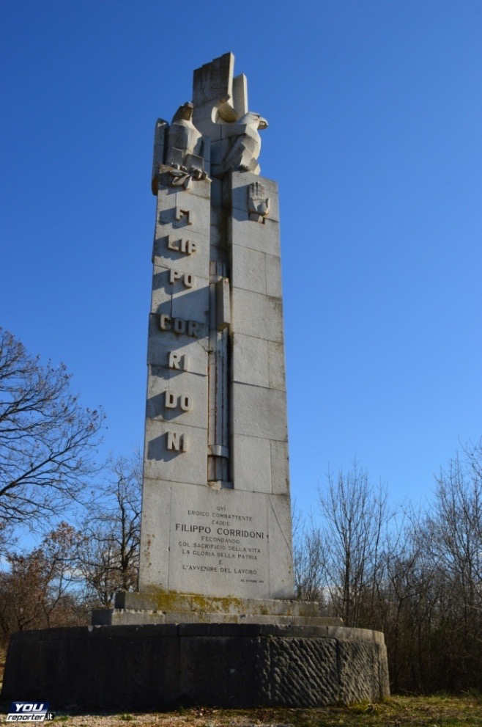
4) Skills: observe and describe - What do you see? ²
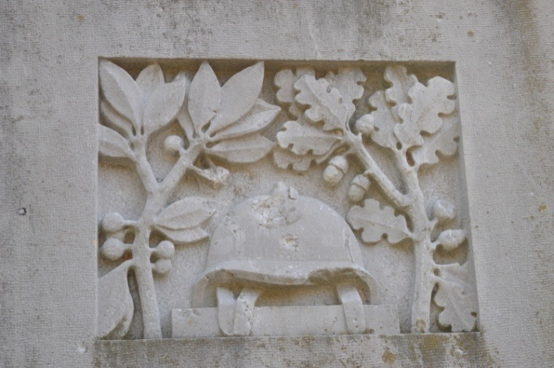

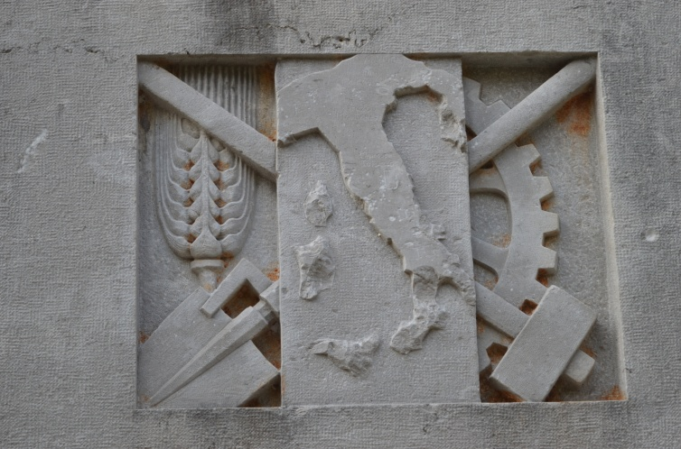

Skills: interpret and argue - With the previous answer and the biography of Corridoni, explain in what this memorial is fascist. Skills: deduct and decode - What are the functions of these monuments ?

5) Skills: Synthesize and argue - What is a war hero? Explain by using the previous answers.

6) Skills: realize – Make a propaganda’s picture by using the previous answers.

¹https://upload.wikimedia.org/wikipedia/it/8/83/Filippo_Corridoni_durante_un_comizio_interventista_a_Pavia.jpg
2Made by a professor

http://www.centrostudibeppefenoglio.it/it/articolo/4-29-1146/personaggi/non-albesi-nella-toponomastica/toti-enrico
https://upload.wikimedia.org/wikipedia/commons/thumb/8/82/Beltrame_EnricoToti.jpg/220px-Beltrame_EnricoToti.jpg

