World War One and Tourism
In Friuli there are a lot of tourist attractions, for example the fronts from the First World War One (WW1) are very important for military tourism. The term military tourism does not apply to a specific form of holiday. Moreover it is a general definition for a holiday whose competitive-advantage-carrying component has a military background.
(Skill: Narrate) - What was tourism like in the past?
Military tourism was born just after the end of First World War, when the soldiers families started to mourn on the sites where their relatives died in war. In the 30’s this kind of tourism became more important in Friuli thanks to the construction of memorial monuments like Redipuglia, Oslavia and Caporetto (Slovenia).
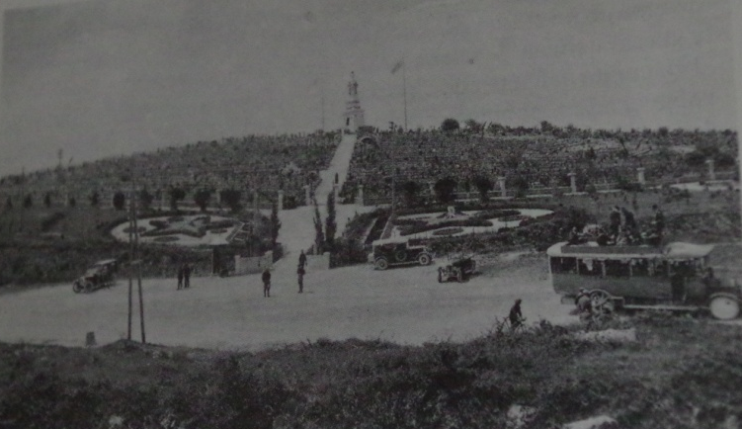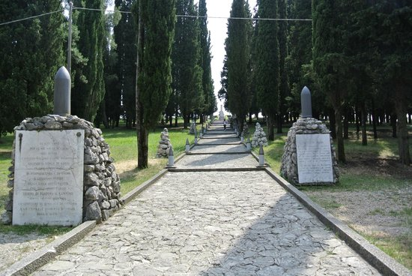
n.1
n.2
Colle Sant’Elia past (1 Century ago) and present (now the soldier’s remains are in Redipuglia monument)
First picture: Redipuglia il sacrario, la guerra, la comunita by Lucio Fabi for Laguna 1993, page 9
Second picture: 28/02/2016 Maurizio C. on tripadvisor

(Skill: differentiate) - How did military tourism evolve?
Because of the invention of the TV and internet the information about monuments became highly available. Nowadays it’s also easier to travel because of the improvement of the roads and the transport. Tourism also evolved because of famous people and celebrities (Pope, president..) advertising the memorials. Today the sites are more prepared to welcome tourists, for example there are large parking spaces, a lot of toilets, restaurants, picnic areas and accommodations. Tourism is a good way to teach people we can solve arguments without war. It shows that war is terrible and educates peace. There are different ways to value memorials, for example you can combine sports (running, biking…) and war education (like in the picture below). You can go to the museum and watch old pictures and movies, but you can also go on the place to see what it looks like in reality.
Near Austrian trenches in Monfalcone (Friulia Venezia-Giulia)
Picture of: P.GALAN 8 March 2016
N.3
(Skills: recover and find) - Where can we find information about the sites of World War One?
If you’re a tourist you can prepare your own itinerary. For this you can consult many different websites, where you can find a lot of pictures.
Two of them are:
http://www.prolocofoglianoredipuglia.it/
http://www.ccm.it/
Starting from the first site you can move on to more specific ones:
-Redipuglia: it’s the famous sacrarium where the major commemorations takes places.
-Colle Sant'Elia: Park of Remembrance
-Austro-Hungarian cemetery
-Mount Sei Busi: remains of the Italian and Austrian trenches
-Trench branches
-Monte San Michele: is home to the Cave gen Lukachich, the SchönburgTunnel and the Gallery of the Third Army.
-Museums and Castles from WW1
-Monfalcone : Theme Park of the Great War 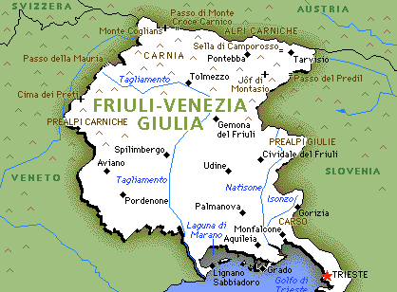
This map is from the blog : http://1.bp.blogspot.com/-hkvimuVdrBw/ThpPYSU30ZI/AAAAAAAAAxA/o0mOC2Km1Lk/s1600/friuli_venezia_giulia_map_political_regions.gif

(Skills: argue) - How do we value our cultural heritage?
Cultural heritage is valued with websites (as written before), local infopoints, booklets, layouts of monuments and reconstruction.
All the sites offer interesting things about First World War and some of them are also equipped with short films (as in Redipuglia’s museum) and a wide range of historical artifacts. Free booklets are given away to tourists with information about the region’s cultural heritage.
On websites you can find information about the places where you can sleep and eat during your trip. This information is also available on the booklets. It’s possible to used credit cards for payment.
If you don’t have access to the internet you can ask for information at the local info points.
If you desire you can ask for a private tour with guides that are specialized on the history of this monuments and places. (Like you can see below)
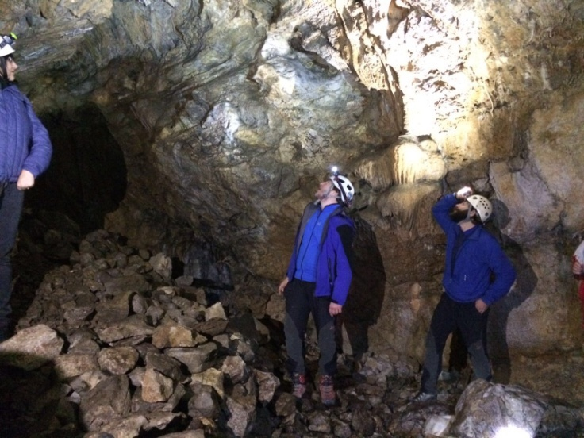
n.4
Guides in Cave that the soldiers used for protection (Monfalcone) Theme Park of the Great War
Picture of: Nicola Martina on the 8 March 2016
Europe and region finances the cultural heritage and it also established a law because it’s important to promoted peace. Military tourism is a good for Italian economy, because tourists have to pay for their hotel, food.

