MONUMENTS AND CEMETERIES OF WWI

06/03/2016-12/03/2016

Made by: Brezočnik Vesna, Carrara Siria, Eierhoff Birthe, Fontana Lisa, Gambarotto Emma

Erasmus+ project
- THE IMPORTANCE OF MEMORY
The considered monuments are all memories that speak about the relationship between the collective experience of death and the exercise of power. The monument is always an union of meanings and forms, related to the historical events. It represents a way to remember and implies a choice: we can not remember all events and situation so something has to be excluded. The monuments are a way to learn about the past and at the same time are celebrative buildings, that have the function to create a collective identity for the future. Mixing past and future it tries to create a new future conception of peace and a world without any kind of conflict in memory of the million peoples death during WW1. So the monuments becomes a public memory sight, it differs from the personal reminders. Although the architecture of the monuments and cemeteries is majestic, on the other hand the death of soldiers wasn’t something we should be proud of. It teaches us that the relationship between monuments and the real inhumane sacrifice is always characterized by the conflict.

- ARA PACIS MUNDI
The Ara Pacis Mundi of Medea is a monumental complex created in 1951 to symbolically commemorate soldiers who died in all wars. Its idea was promoted by a National Committee formed by the main war veterans associations and the Assistance Committee of the Vatican after WW II.
Skill: Recover and Find
The position
The Hill of Medea was the location chosen for this monument; Medea is a small village in the Friulian plain, halfway between Gorizia and Palmanova, a former observation point of king victor
Skill: Observe and describe
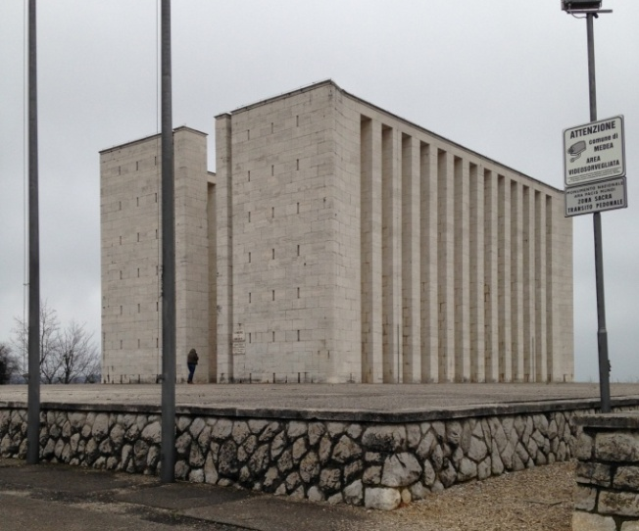
The structure
The meaning of Ara Pacis is tha altar of peace. It is a sacral corral that safeguards an urn. The urn contains some clumps of 800 war cimitery and some water of the sea theatre of battles.
The construction of this monument started on the top of this hill, at 135m ASL, in late December 1950 under the direction of engineers Sirtori and Mocellini and following a project by architect Mario Bacciocchi from Milan.
The imposing monument covers an area of 1550 sqm and took less than 6 months to complete. A staircase from the parking lot leads to the Ara Pacis surrounded by a massive fence in travertine marble. The sides facing north and south are open in the middle, while the side facing east consists of 14 close pillars, each 13m high. Inside, you can see the actual ara (altar), built in porphyry from the Camonica Valley, 3m long and 5m high, squared. In the plant, the structure seems to be symmetric, but, to tell the truth, the east face is composed by 12 pillars free until the architrave. Unlike it, the west face is free only in the inferior part.
Inside this altar, an urn in wood and bronze bears the inscription Odium parit mortem, vitam progignit amor ("hatred produces death, love generates life"). The urn holds the soil of 800 war cemeteries in Italy (including foreign cemeteries) and, following a blessing received on the Altar of the Fatherland in Rome, was brought to Medea and placed inside the altar on 06th May 1951.
(coll priveé)

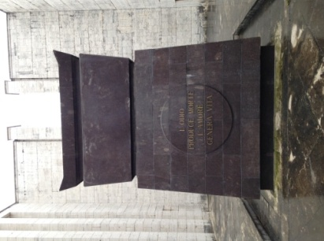
Skill:Narrate
Feelings:
At first glace the monument seems to be a compact structure without entries and exits. It creates a distance between the monument and the viewer. Indeed the height of architecture makes the viewer powerless. So the monuments seems to be insurmountable producing the feelings of soldiers in front of war.
Moreover when you go inside the monument you see an altar; it adds meaning because it is collocated at the centre of internal structure and its colour creates an opposition with the colour of the whole structure.
(coll priveé)

The sentence wrote on the altar is full of meaning: it underlines the consequences of war and the importance of peace and humanity for the world.
A relevant element is the roof; it creates a contrast with the first viewer’s impression, because in place of oppression, the viewer feels to have an opportunity to escape and put an end to the war.
Skill: Analyze and Interpret
Symbolism:
This monument was meant to symbolically lead men towards peace and brotherhood without the need of resorting to the cruelty of war. The monument is placed on a hill; it raises an immediately and heroic suggestion.
Interesting is it to notice that the frontal face seems to represent different cultures, ideologies and identities. Indeed the monument wants to be a symbol of whole soldiers and countries. The symbol has to transmit memory of the fallen, without distinguishing the faith, nation or race. Moreover it is the only initiative to commemorate fallen without differentiation.
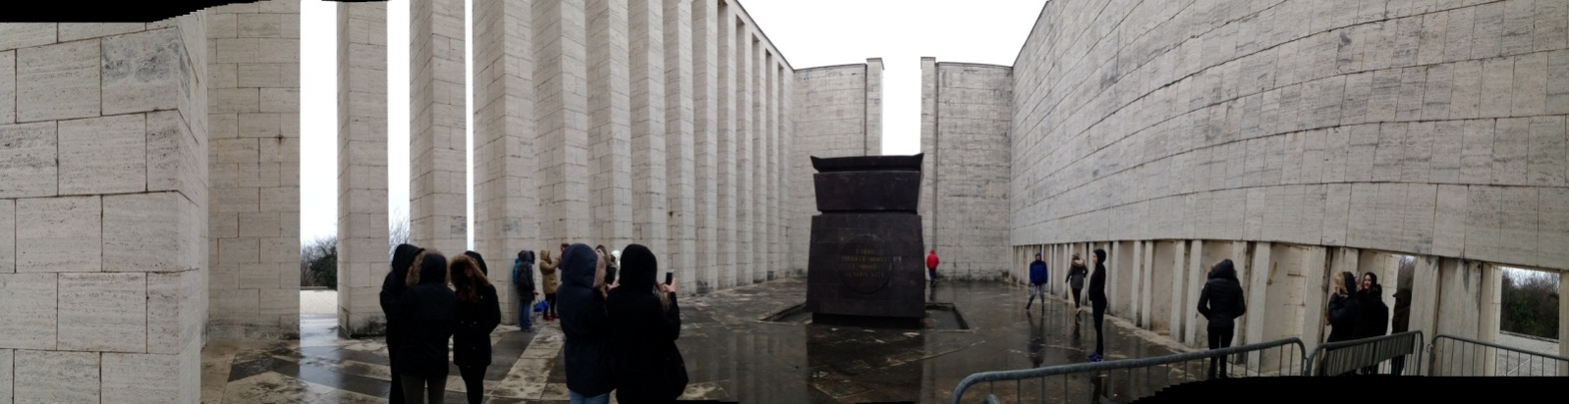
Various glass cruets contain water from Ionic, Adriatic and Mediterranean Sea, where ships from different nations were sunken and a lot of soldiers died.
The Memorial Ara Pacis Mundis is a symbol of the sacrifice for the country and it represents the hope of a world of peace, liberty and justice.
(coll priveé)

- CIPPO FILIPPO CORRIDONI
Skill: Recover and Find
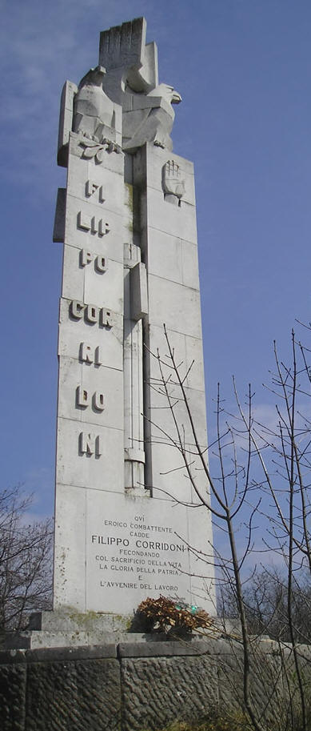
The position
The monument was built near the trench of the Frasche. It is located on the main trail of the Battle Area, near the Sassari Brigade Memorial. This trench is important for the twelve battle of Isonzo.
Skill: Observe and describe
The structure
This 23m high memorial is well visible from afar. It was designed by sculptor Francesco Ellero from Latisana, and personally ordered by Benito Mussolini in 1933 to homage his old friend, who had never found an adequate resting place before. On the monument we can see the open right hand, the eagle looking eastwards and the fasces all along the sides.
Skill: Analyze and Interpret
Symbolism
The monument recalls some typical elements of fascism: the open right hand remember the traditional Roman salute and eagles represent the power of fascism. The monument is dedicated to Filippo Corridoni, who fell here on 23rd October 1915, during the Third Battle of Isonzo. It is important to notice it was made for a singular leader ,Italian trade unionist and syndicalist.
So the celebration of singular heroes, personification of whole nation, corresponds to the relationship between power and population in the fascism period.This sentence argues it'qui eroico combattente cadde Filippo Corridoni fecondando col sacrificio della vita la gloria della Patria e l'avvenire del lavoro'.
(coll priveé)

This information creates an opposition with the Ara Pacis Mundi, because it represents only a celebrative monument and not a moment to reflect about the brutally of the war.
Another element to notice is the interventist character of Filippo Corridoni. One of his most famous sentences is “Il popolo non crede ai cultori delle cedole bancarie. Crede all'azione, a chi gli indica le vie del destino. Crede soprattutto a chi gli aprirà le strade vere della giustizia sociale.” (“people don’t believe in banks. They believe in action, in people who show them the future. They believe in those who show them the true way to achieve social justice”) He was very closed to Mussolini in 1914-15 representing a model for him. He was for the entrance of Italy in the war besides England and French.
- CEMETERY OF HEROES IN AQUILEIA
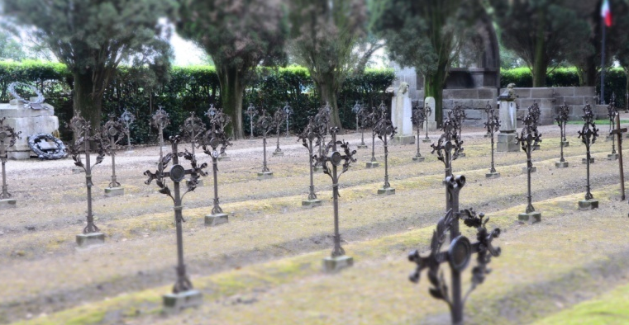

(coll priveé)
Google maps

Skill: Recover and Find
The position
The cemetery is located in Aquileia, behind the old Roman city walls, next to the cathedral of Our Lady of Assumption.
Skill: Observe and describe
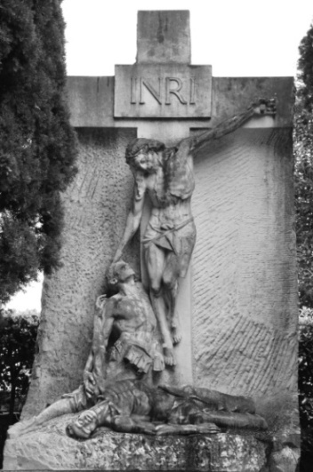
The structure
It is historically important because unlike other cemeteries it has maintained its original shape since 1915. The cemetery and the place are connected to the story of the unknown soldier, who is buried in Rome. During later years of the war the bodies of many fallen soldiers of the Karst were transferred in large memorials and ossuaries at the cemetery of Aquileia. Don Celso Constantini was a military chaplain in the Italian Army in the WW1. The crosses were decorated with laurel and oak leafs, each cross has engraved “Dulce et decorum est pro patria mori” which means, “To die for the Motherland is sweet and dignified” and the names of those who rest there.
At the cemetery we can find many important monuments like the arcosolium, with the 10 unknown soldiers, Commander of the "Tuscan Wolves" and General Alessandro Ricordi. Here lie the rests of Maria Bergamas Giovanni Randaccio, who lost her son during the war. Because of that she was able to choose one of the 11 dead bodies to be transferred to Rome as a symbol and in honour to her son. The two most interesting sculptures on the cemetery are "The Sacrifice" by Edmondo Furlan (1921)(photo 1), representing Jesus Christ on the cross comforting two dying soldiers and "The Angel of Charity" by Ettore Ximenes (1917) (photo 2), showing a dying soldier and a female figure.
Skill: Analyze and Interpret
The symbolism
He wanted the graves to look similar to each other, so all the soldiers were equal: all the same size. To embellish the cemetery, he used some plants from different parts of Italy as a decoration. The association “Dante Alighieri” donated iron crosses, which were created by sculptor Alberto Calligaris. Nowadays people still remember all the fallen in war, so on 1st November of every year the Fiaccola Alpinadella Fraternità comes from Timau to remember all the fallen soldiers.
(coll priveé)

(coll priveé)

- CONCLUSION
The cemetery is a symbol of sacrifice of millions of people. It is the place where you can go to glorify them. The way it is organized shows that every man is the same in front of the death, no matter where was he from and who was he. The huge number of crosses in each cemetery shows us there were many victims, which leads us to the conclusion that many families were destroyed. From this place we achieve the consciousness about the terrible consequences of the war, and the will to never make them happen again. A huge number of war monuments is dislocated on the national territory of the countries which joined the WW1. They underline the State’s will to stabilize the war experience in order to sacralise it and constitute a public counsciousness.
Sources:
http://www.turismofvg.it/Monumenti-e-Siti-Storici/Ara-Pacis-Mundi
http://www.itinerarigrandeguerra.it/Ara-Pacis-Mundi-di-Medea
http://aclfoto.net/360VR/?p=233
http://aclfoto.net/360VR/?p=233
http://www.itinerarigrandeguerra.it/Cippo-Filippo-Corridoni-San-Martino-Del-Carso
https://it.wikipedia.org/wiki/Filippo_Corridoni
http://expoaus.org/aquileia-uso8
http://www.turismofvg.it/Sfogliabili/Mappe_Tematiche/Inglese/Mtem_EN04_First_world_war/files/assets/basic-html/page17.html

http://www.itinerarigrandeguerra.it/code/33060/Cemetery-of-Heroes-of-Aquileia
http://aquileia.arte.it/art-guide/aquileia/must-see/monument/cemetery-of-heroes-5264

