Celina, Wiesker
- Stereotypes
- German
- American
- War Propaganda
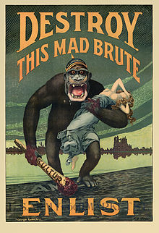
Destroy this mad brute
This image was used during the First World War as war propaganda. It shows a monkey and an innocent woman whom he kidnaps.
The big monkey shown on this poster should symbolise the Prussian emperor, which is clearly shown by the spicked helmet and the moustache. During the time, this was used as war propaganda.
Darwinism was coming up. Charles Darwin was an English naturalist who published “On the Origin of Species” in 1859.Charles Darwin is the founder of Darwinism, a theory of biological evolution by developing through natural selection. Darwinism is usually strictly used as a term for biological evolution but creationists and politicians later on used it. Darwinism became a term in biology, social studies and philosophy. Philosopher Herbert Spencer summed up one of the central aspects of Darwin’s observations as “Survival of the fittest”, which was often miss used in the society. Some people thought that Survival of the fittest means that the “superior” will overwhelm “inferior” races. They used it as an excuse to attack the “inferior” ethnic groups, countries or races.
By presenting the emperor as an animal, they take away the entire human trait and declare him an animal, even a “mad brute”. The blood on his hands makes the image of the Prussian emperor seem even more cruel and brutal. Germany is stereotypically presented to simplify the enemy. By simplifying the enemy and using stereotypes, an enemy loses any good traits and now, because the enemy is no human anymore, fighting against them is legitimized.
The “mad brute” crosses the American border and enters their territory, which means that he will start attacking America on the American ground. It threatens the viewer and calls for action.
(https://de.wikipedia.org/wiki/Propaganda_im_Ersten_Weltkrieg)

- Find out about typical “German” features of the poster. (Recover, Find)
- Find out about the war entry of the United States. (Recover, Find)
- Describe the title of the caricature and the figures represented. (Analyse and Interpret)
- Discuss central visual effects and intention. (dimension, position, perspective, Colors, texture)
(Analyze and interpret)

- Contextualize the imagery with the help of additional information on central religious and scientific influences of the time. (Recover, Deduct, Cultural awareness and expression)

