Wiesker, Celina
Keywords: autobiography, family, chronicle, living conditions
Summary:
To give a brief overview, I want to illustrate the sources I have been working with.
I found my material in a family chronic (Geschichte des Hofes Mormann 17. - 20. Jahrhundert) and translated it in English and summarized the content.
Joseph Watermann for example was a “Unteroffizier-Aspirant” who had to serve in the war and was mobilized on 1 August, 1914. Jospeh had to fight in Belgium and was later listed as missing. After a while he contacted his family from a military hospital in Westphalia. After he had fully recovered he was sent to the eastern frontline in northern Poland.He became an officer. He was injured by Cossacks. When he wanted to return to the war area the revolution in Germany was causing the resignation of the emperor, and the war was lost. The resignation was hard for Joseph because he had been a loyal soldier.
Maria Watermann was diagnosed with cancer and her husband Heinrich Watermann was suffering from an asthmatic illness, which both had probably been caused by the chemical intoxication in the First world war.
Joseph Lenfort was ordered to the military in November 1916. He had to fight in Frnace where his where his two older brothers died.
Franz Schröer was 18 years old when he was ordered to the military service. He fought in the First world war in France (Fed-Art. Rgt. 269, 6.Baterie) in the section at the front at the Somme, in Lorraine.
Furthermore, I worked on the chronic of the shooting club Grinkenschmidt from Altenberge which gave some general information about the situation in Germany in a whole during the WWI.
It was often propagated by the German publication that the German people enjoyed fighting in the war and the war propaganda was strongly interested in making the war look “easy” and “honorable”. The soldiers discribe it differently. The soldiers were homesick and afraid.
After the war the black markets were booming and the people from the cities were willing to pay nearly any price for their food during their “Hamsterfahrt”. During a “Hamsterfahrt” thepeople were buying or sometimes stealing food in great quantities. The social life was inactive during the war.
Remembering the victims among friends and brothers and fathers was important.

My Material – Erasmus 2015

On the following pages, I will show my material that I collected for the Comenius project in 2015. I searched for a connection between my own family and the First World War (1914-1918). I searched and talked to many members of my family and had to realize that the memories of the people are quite dominated by the events of the Second World War. Because of this dominance, it was difficult to find material like letters or pictures in my own family.
Nevertheless, I found a book about my family’s history going back into the 17th century until the 20th century (Geschichte de Hofes Mormann 17.-20. Jahrhundert).In the book I found some passages that were dealing and describing the situation in the First World War.
In addition to this chronic, I found a commemorative publication (Festschrift 1924-1999) that describes the situation in the First World War and the consequences for the public life specially focusing on the Schützenverein Grinkenschidt e.V., Altenberge.
I will start this collection with the family chronic.
Josef Watermann & the WWI :
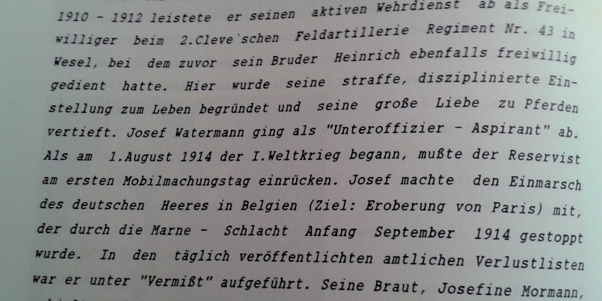
Josef Watermann was born on the 29.08.1890 in Altenberge. He went to the basic primary and secondary school in Altenberge. 1910-1912 he voluntarily did his military service at the 2.Clev`schen Feldartellerie Regiment Nr. 43 in Wesel, where his brother had also did his military service. He left the military as an “Unteroffizier-Aspirant”.
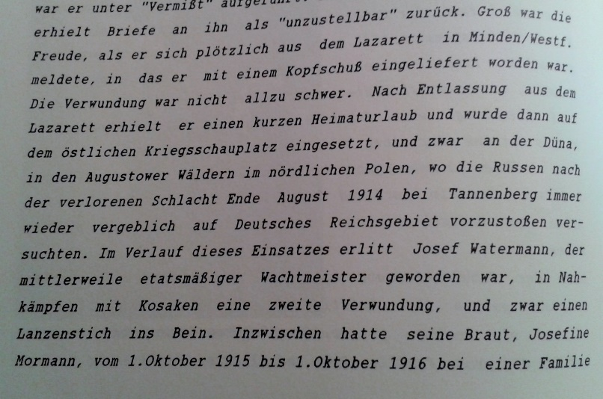
When the First World War started on the 1st August 1914 he had to enter the general mobilization. He marched into Belgium with the German military (the aim was to conquer Paris) when the battle was stopped in 1914. In the daily published list of missed he was also mentioned. His fiancée wrote him letters but they were not able to deliver it to him so the letters came back.
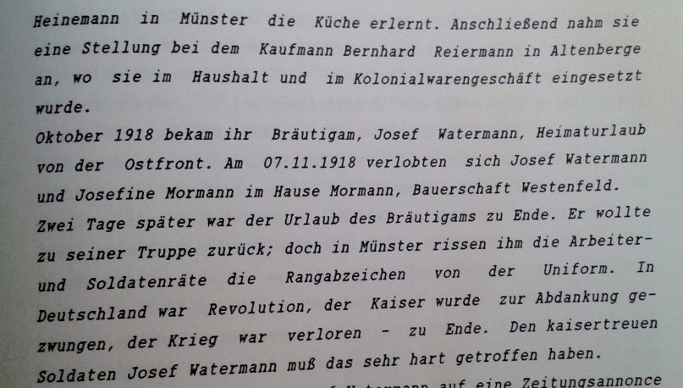
Josef Watermann contacted his family from a military hospital in Minden (Westphalia). He had be wounded at the head but the injury was not that dramatic. He had a little holiday before he was send to the eastern war area in northern Poland. Josef Watermann became an officer and was injured by Cossacks (they stabbed him in the leg with a lance). In October 1918 he got holidays again, He wanted to return to the eastern war area on the 07.11.1918 when the revolution in Germany caused the resignation of the emperor and the war was lost. Josef Watermann was a loyal soldier to the emperor and the events must have been hard for him.

The fate of Maria Watermann:
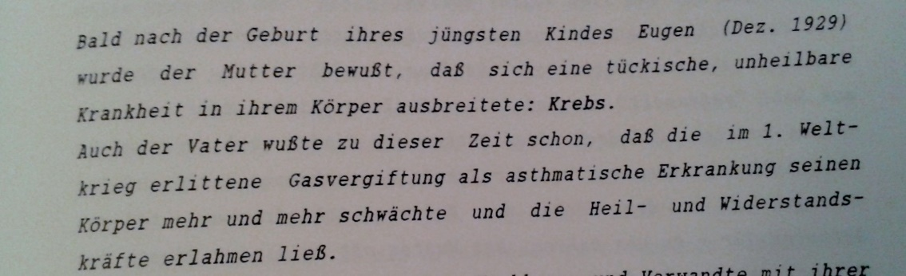
Maria Watermann gave birth to her youngest child Eugen in December 1929 when she realized that something was wrong with her. She was diagnosed with cancer and her husband Heinrich Watermann was dealing with an asthmatic illness, which was caused by the chemical intoxication in the First World War.

Josef Lenfort and his brothers fought in the WWI:
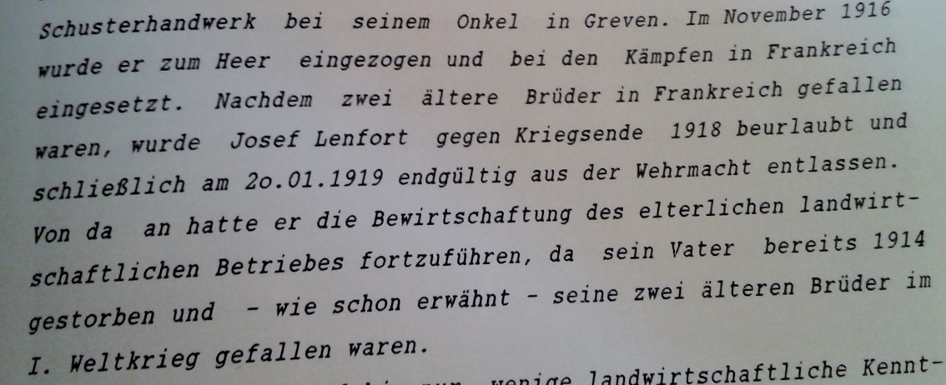
Josef Lenfort was ordered to the military in November 1916. He had to fight in France where his two older brothers died. Josepf was on sabbatical in the end of the war in 1918 und he was finally released of the military on the 20th January 1919. Thence he had to run the farm of his family on his own because his brothers died in France and his father had passed away in 1914.

Franz Schröer- an 18 years old soldier:

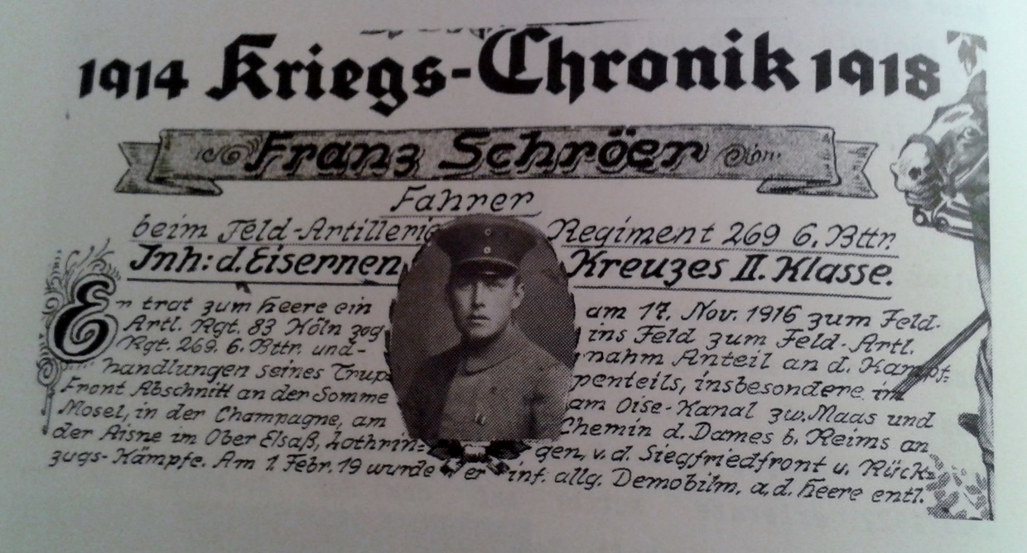

In the middle of November 1916 the only 18-year-old boy, Franz Schröer was ordered to military service. After his basic training period at the “Artl. – Rgt. 83” in Colone he fought in the First World War (“Feld- Artl. Rgt. 269, 6. Baterie) in France. Especially fighting in the section of the front at the Somme, in Lorraine. He survived the war without injuries and left the military service on the 1st February 1919.

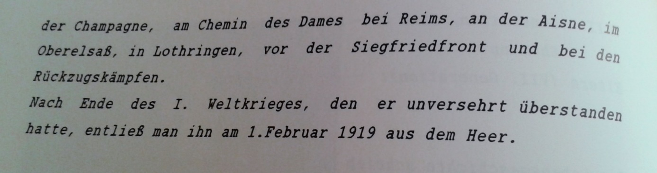
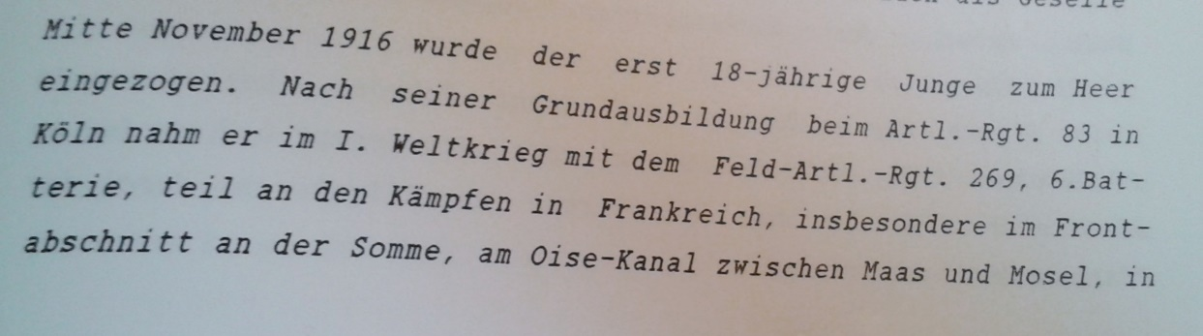

1. Weltkrieg und Schützenfest- First World War and shooting clubs festival

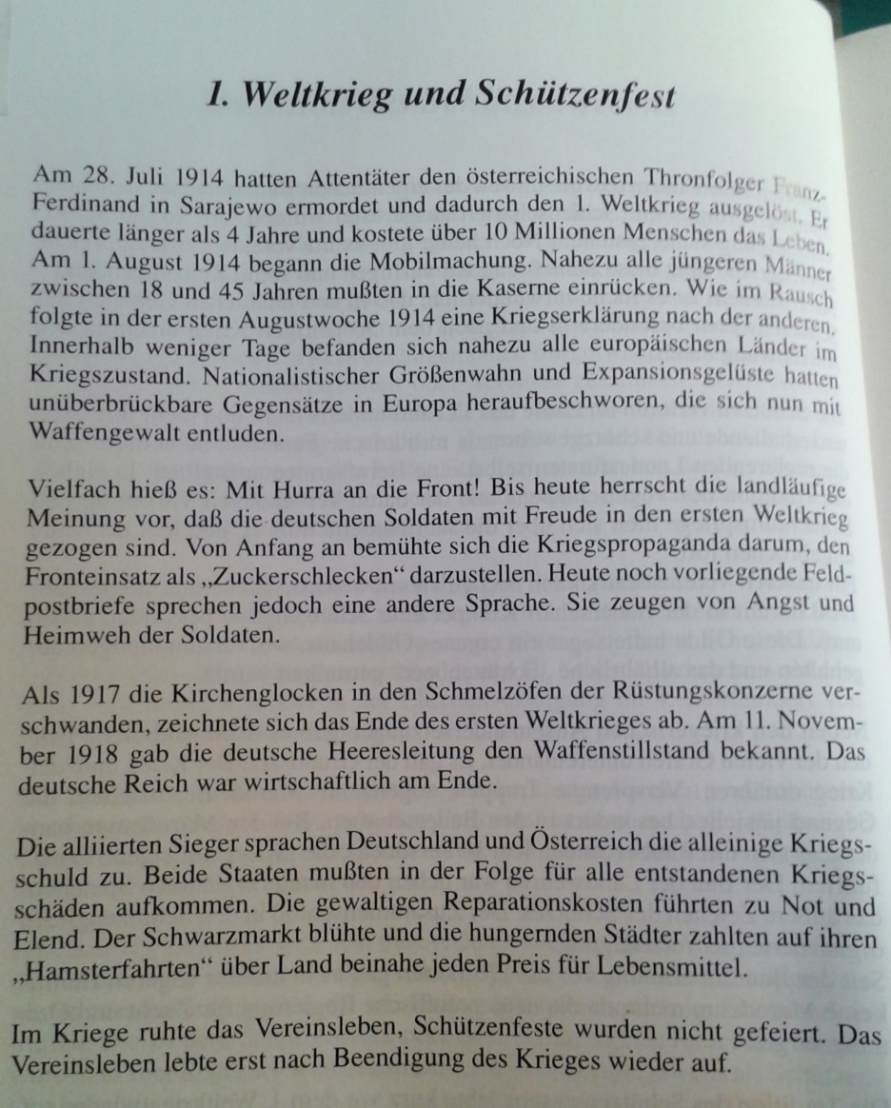
The text describes the events in and the general situation in the First World War. It start by giving the cause of the First World War, the murder of the Austrian Prince Franz Ferdinand in Sarajevo. The war led to over 10 Million deaths in four dramatic years of war. The general mobilization started on the 1st August 1914. It is mentioned that in the first week of August declarations of war were spoken out nearly every day and within a few days, almost all European countries had war.
It was often said that the people in Germany enjoyed fighting in the war and the war propaganda was keen on making the war look easy to win.
Even though the war propaganda was very engaged in making the war, look good the letters of soldiers tell something else. The soldiers were homesick and they were afraid.
In 1917, the church bells were used to produce more arms and the end of the world war was coming. On the e11th November, the German army command declared an armistice. The German empire was economically destroyed. The allied forces declared that Germany and Austria have the sole responsibility for the First World War. The high reparation depts. caused poverty and hunger. The black market was booming and the people from the cities were willing to pay nearly any price for their food (Hamsterfahrten).
During the war, the social life and the shooting club festivals were inactive. After the end of the war, the social life and the Shooting club festivals started to rise and live up again.

Memory of the victims- Gedenktafel in der Madonna an der Landstraße

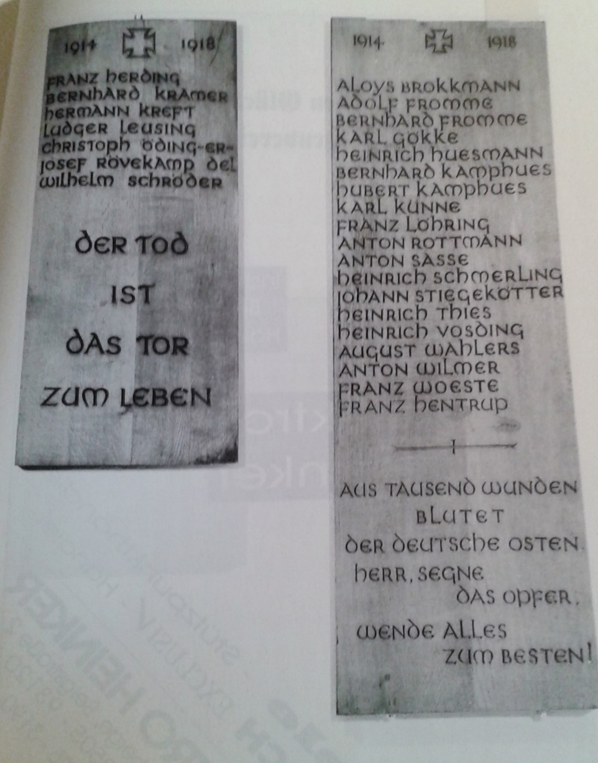
Remembering the victims of the First World War is still part of every shooting club festival. The victims that were brothers, fathers and sons are not forgotten. The names of the victims are accurately written on wood and they hang in the chapel. It was built for the members of the shooting club that died in the Second World War. The members built it all on their own and the ones who could not participate by building it donated money to help. Today the services during the festival are still celebrated in this chapel and it is a place of history and at the same time of safety.

Résumé:
To end this collection I can say that the First World War demanded his victims and I am surprised that my family has such a connection to the war and had to list deaths. I think it is a great sign that the shooting club built up chapel to remember the victims even though it is for victims of the first and the Second World War.

