„The rest is ... Austria“ – The end of World War One as a caesura of Austria’s history

In November 1918, while people in the countries of the Entente were celebrating the victory and the end of murderous World War One, in Austria a complete new political situation was on the horizon. After centuries of monarchy rule the republic was proclaimed on the 12th of November 1918.

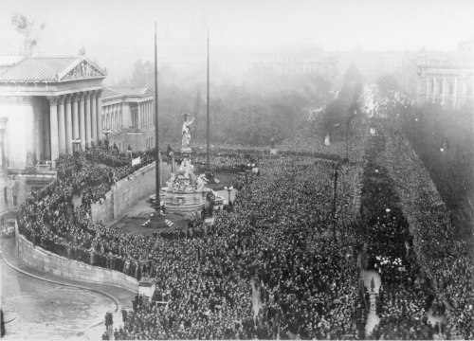

Proclamation of the Austrian Republic in front of the parliament in Vienna
source: Austrian National Library

For the new government the end of the war meant dramatic changes and created a new political framework. Numerous ethnic groups had left the political institution of the monarchy and had founded an own nation. Being deprived of full equal rights nationalism had flourished in the remote provinces of the empire. The death of emperor Franz Joseph II. in 1916 denoted the loss of the most important tie that held the multinational, multilingual and multireligous empire together. His successor emperor Karl I. attempted to restructure the realm but without success, with reference to Wilson’s right of people to self-determination several new nations arose.
The Austrian provisional government faced grave structural problems:

The independence of the Danube Monarchy’s peoples meant not only a huge decrease of the country’s population from about 51,4 million in 1910 to about 6 million, but also the abrupt ending of centuries-lasting economic relations. Being fed up with Austrian hegemony the new countries cut the old bondings and established own domestic markets. The remaining Austrian economy was especially hit by the loss of the industrial power of Bohemia’s economy with its coal and steal industry. Also Hungary’s independence caused severe supply problems with Austria being cut off from Hungarian agricultural production by protectionistic measures.

Therefore Austrian trade relations had to be completely restructured. The focus of imports and exports had been on Southeast Europe, Austria’s capital Vienna lost its importance as the leading hotspot in the region and was put in a rather periferic position within Austria’s new topographic and economic situation. With the loss of Trieste and the surrounding area Austria also lost its direct access to the sea changing the country’s geopolitical status to a landlocked country. Besides the economic problems, the foreign affair issues with the State of Slovenes, Croats and Serbs and with Hungary concerning unsettled boundaries occupied Austria’s government.

Within the country the situation also looked rather bleak. The Austrian administration being arranged for a nation of 670.000km² was now plainly oversized. Soldiers returned from the front – disenchanted and in many cases war-damaged. For many the remaining part of the former empire was literally not viable. Two of Austria’s now nine states joined the federal state only with reservation. Tyrol attempted to establish a free state in order fend off the loss of South Tyrol, the state of Vorarlberg asked Switzerland for admission but was rebuffed.

Most of the political elite in Austria were in favor of an association with Germany, but the terms of the Treaty of Saint-Germain-en-Laye prohibited a federation. The reaction to the provisions ranged from incomprehension to pure shock. Apart from the monarchists, nearly all political players had planned with an integration within the new German state. German-traditionalists saw themselves als German speaking cititzens with cultural ties to its northern neighbors. Socialdemokrats thought that the country lacked the strength to start the socialistic revolution by itself.

Within the population the prohibition led to protests and outcries. Austria – that were the remains of a cut-down empire, now being patronized by the victors of the war. For many the drastic changes within this short amount of time were traumatic. It took decades including the tragic experiences of World War Two and the Holocaust to ripen the Austrian’s self-portrayal as an independent nation.

Facing these challenges the provisorial government in November 1918 was nonetheless successful in organising the first democratic election already in Februar 1919. It was the first plebiscite with women being able to caste a vote and and women being elected members of parliament. A new chapter in Austrian history had begun.

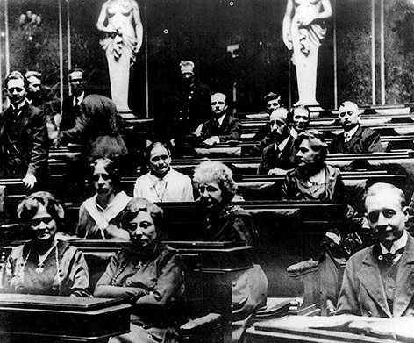

The very first emale members of parliament
source: VGA /AZ-Bildarchiv

List of references:

Binder, Dieter: Von 1918 bis zum ständestaatlichen Kokettieren mit dem Legitismus. In: Eigner, Clemens et. alt. (Pub.): Das Habsburger-Trauma. Das schwierige Verhältnis der Republik Österreich zu ihrer Geschichte. Wien 2014

Eigner, Peter: Untergang oder Aufbruch. Zur Ausgangssituation des neuen Österreich 1918. In: Österreichische Wirtschafts- und Sozialgeschichte im 19. und 20.Jahrhundert Wien 1999

Fassmann, Heinz/ Hatz Gerhard: Wien. Städtebauliche Entwicklung und planerische Probleme. In: Wien. Städtebauliche Strukturen und gesellschaftliche Entwicklungen Wien 2009

Karner, Stefan: Folgen des Ersten Weltkrieges. In: 1914-2014. Grundlagenpapier ö. Wissenschaftlerinnen und Wissenschaftler aus Anlass des Gedenkens des Ausbruchs des Ersten Weltkrieges vor 100 Jahren. Wien 2013

Leser, Norbert: Zwischen Reformismus und Bolschewismus. Der Austromarxismus als Theorie und Praxis. Wien 1985

Melichiar, Fritz et. alt.: GO! Geschichte Oberstufe 7. Wien 2013

Moritz, Verena: Nachwirkung der „Fronterfahrung“ des Ersten Weltkriegs auf die Entwicklung Österreichsin der Zwischenkriegszeit . In: 1914-2014. Grundlagenpapier ö. Wissenschaftlerinnen und Wissenschaftler aus Anlass des Gedenkens des Ausbruchs des Ersten Weltkrieges vor 100 Jahren. Wien 2013

Rauchensteiner, Manfred / Broukal Josef: Der Erste Weltkrieg und das Ende der Habsburger-Monarchie. In aller Kürze. Wien 2015

Rathkolb, Oliver: Es ist schwer, jung zu sein. Jugend und Demokratie in Österreich 1918-1988. Wien 1988

Vocelka, Karl: Geschichte Österreichs. Kultur-Gesellschaft-Politik. Graz 2000

Vocelka, Karl: Geschichte der Neuzeit. 1500-1918. Wien 2010

http://ww1.habsburger.net/en/chapters/myths-and-narratives-rest-austria-or-something 28.06.2017

the saying „the rest is Austria“ is accredited to Georges Clemenceau but never proven. http://ww1.habsburger.net/en/chapters/myths-and-narratives-rest-austria-or-something 28.06.2017
cf. Vocelka, Karl: Geschichte Österreichs. Kultur-Gesellschaft-Politik. Graz 2000, pages 270-272
cf. Rauchensteiner, Manfred / Broukal Josef: Der Erste Weltkrieg und das Ende der Habsburger-Monarchie. In aller Kürze. Wien 2015, pages 15-17
cf. Vocelka, Karl: Geschichte der Neuzeit. 1500-1918. Wien 2010, pages 611-614
adepted from: Melichiar, Fritz et. alt.: GO! Geschichte Oberstufe 7. Wien 2013, page 70
cf. Fassmann, Heinz/ Hatz Gerhard: Wien. Städtebauliche Entwicklung und planerische Probleme. In: Wien. Städtebauliche Strukturen und gesellschaftliche Entwicklungen Wien 2009, page 20
cf. Karner, Stefan: Folgen des Ersten Weltkrieges. In: 1914-2014. Grundlagenpapier ö. Wissenschaftlerinnen und Wissenschaftler aus Anlass des Gedenkens des Ausbruchs des Ersten Weltkrieges vor 100 Jahren. Wien 2013, pages 30-32
cf. Eigner, Peter: Untergang oder Aufbruch. Zur Ausgangssituation des neuen Österreich 1918. In: Österreichische Wirtschafts- und Sozialgeschichte im 19. und 20.Jahrhundert Wien 1999, page 135
cf. ibd., pages 136-140
cf. Rauchensteiner / Broukal, Der Erste Weltkrieg, pages 243-248
cf. Vocelka, Geschichte Österreichs, page 274-276
„Deutsch-Österreich“ the nation’s first name was not accepted.
cf. Moritz, Verena: Nachwirkung der „Fronterfahrung“ des Ersten Weltkriegs auf die Entwicklung Österreichsin der Zwischenkriegszeit . In: 1914-2014. Grundlagenpapier ö. Wissenschaftlerinnen und Wissenschaftler aus Anlass des Gedenkens des Ausbruchs des Ersten Weltkrieges vor 100 Jahren. Wien 2013, pages 33-34
cf. Binder, Dieter: Von 1918 bis zum ständestaatlichen Kokettieren mit dem Legitismus. In: Eigner, Clemens et. alt. (Pub.): Das Habsburger-Trauma. Das schwierige Verhältnis der Republik Österreich zu ihrer Geschichte. Wien 2014, page 13
Rathkolb, Oliver: Es ist schwer, jung zu sein. Jugend und Demokratie in Österreich 1918-1988. Wien 1988, page 14
Leser, Norbert: Zwischen Reformismus und Bolschewismus. Der Austromarxismus als Theorie und Praxis. Wien 1985, pages 130-138
see Article 88 of the Treaty
cf. Karner, Folgen, page 33

