10/03/2016
Pozzetto Alessandro - Tassile Federica - Pasquet Lola - Wiesker Celina - Maruska Slavec- Naja Skrlj

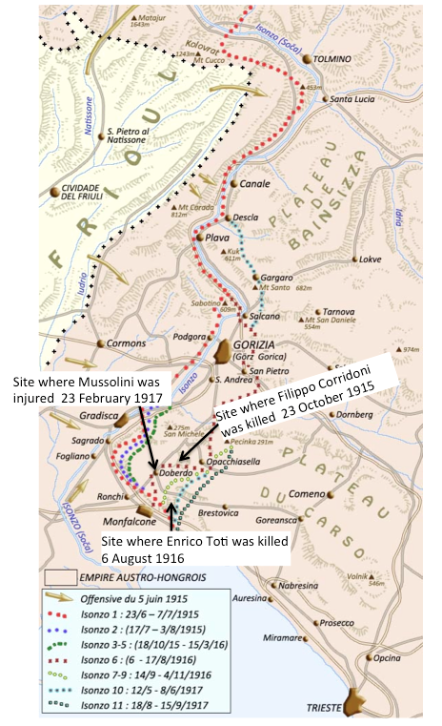
Progetto Erasmus | THE HERO FACTORY

Enrico Toti’s biography

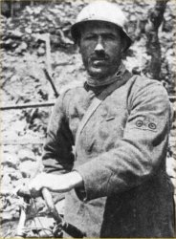
Born in Rome, on 20th August 1882. First he joined the naval school and helped against the pirates in the Red Sea. Later, he joined the State Railways and because of an train accident, they amputated his leg up to his pelvis. He lost his job and began creating small inventions (they are now in Rome). In 1911, he began his cycling journey in Paris, up to Finland and Lapland and returned to Italy through Poland. He wanted to cycle Africa, but did not make it past Sudan due to dangerous circumstances. His recruitment pleas were rejected, so he joined the front in Cervignano as a civil volunteer. The carabineri of Monfalcone sent him home, but he returned thanks to the interest of Duke of Aosta and later became a cyclist bersagliere of the third battalion. In August 1916, the sixth battle of the Isonzo began and concluded with the occupation of Gorizia. On 6th August, Toti and his troop threw themselves at the enemy in a heroic gesture and he screamed: “I will not die!” He was decorated with the highest medal of honor by king Vittorio Emanuelle III in person. He has two submarines and streets named after him, along with two monuments.

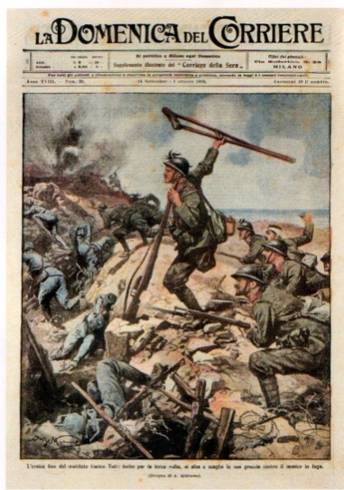
1) Skills: analyze and interpret – With the La Domenica Del Corriere’s front page, explain that Toti is seen as a hero.

In an Italian newspaper, La Domenica del Corriere, Enrico Toti and his heroic death were depicted on the cover. It could serve as a propaganda, because he is drawn as strong, upright, lifting his crutch up in the sky and balancing on his rifle, leading the attack on the Austrian army. His Italian comrades are portrayed as brave and fearless. On the other hand, the Austrians are depicted as weak, cowering behind the trenches, half dead already. Toti is drawn in the middle of the drawing, and also elevated, standing on a trench, so he is in the centre of the drawing. His crutch serves as balance between the smoky explosion on the left (Austrian territory) and the clear sky on the right (Italian). It is definitely stylized and romanticized, because it probably did not happen like this, with Toti leading the attack and the Austrians so weak. The description under reads: “The heroic end of mutilated Enrico Toti, wounded for the third time, he rises and throws his crutch against the enemy running away.”

Skills : Digital skills – Search how can we honor Toti.
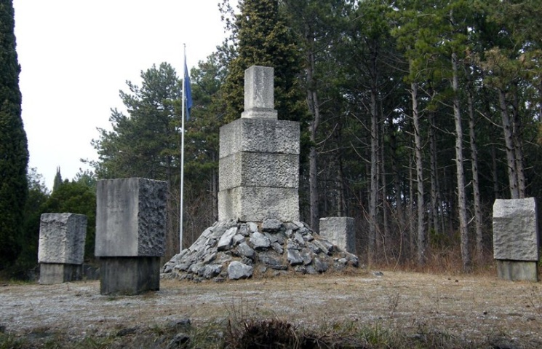
In the Park of the Great War of Monfalcone there is the trench portion 85, also called "Enrico Toti" in honor of the famous Italian volunteer who right here lost his life during the Sixth Battle of the Isonzo. Here you can see the deep entrenchment in the rock reinforced with concrete parapets made by the Italian services, using the previous Austro-Hungarian excavations. Behind, in the valley, some artillery emplacements and the ruins of the garrison barracks are visible.
On the trench portion 85 you can also admire the impressive monumental area in memory of those who fought on the heights of Monfalcone during the Great War. They are remembered with memorial stones coming from the different departments which were present between 1915 and 1917.The fighters killed have been awarded with a gold medal for valor.
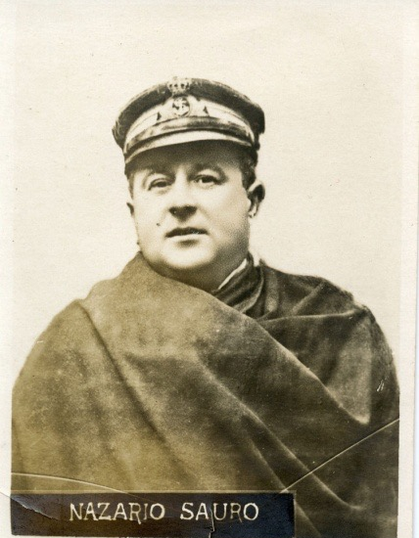
Nazario Sauro’s Biography
Nazario Sauro⁶ (Capodistria, 20 settembre 1880 – Pola, 10 agosto 1916) was born in Capodistria (present-day Slovenia) which at the time was part of the Austro-Hungarian empire.He was an Austrian-born Italian irredentist. Nazario finished the school with good grades and his father wanted him to continue studying but his real passion was the sea. He had started sailing at a very young age, and when he turned 20, he was already the captain of a cargo ship.His passion for the sea influenced his later job. After Venice was annexed to Italy irredentism came up. Irredentism is a Italian- nationalist ideology that promoted the reoccupation of the lost territories. Nazario strongly supported this ideology and therefore voluntarily involved himself in the war against Austria even though he was born as an Austrian.Nazario signed up for the Navy and was promoted Sub-Lieutenant in June 1916 and was awarded a silver medal (Italian: Medaglia d'Argento al Valore Militare), which honors courage. He had helped to accomplish sixty military missions.His submarine, of which he was pilot, crashed into a rock on the 30th June 1916 in the Kunvar Gulf and the crew was intercepted by an Austrian destroyer ( military ship).Sauro was imprisoned and put on military trial because of his previous act of treason. After the trial Nazario Sauro was sentenced to death and hanged on the 10th august 1916.

2) Skills: analyze and interpret - Why people considered him a hero?
- He fought and died for Italy even though he was an Austrian citizen
- helped in many missions he was keen on fighting for Italy
- during the fascist regime the image of a hero gained more importance
Why was irredentism important and topical during that period of time?
- Strong feeling of nationalism
- borders changed rapidly and gaining back territory was important
Why is Nazario Sauro presented as a national hero and by which means?
- Monuments
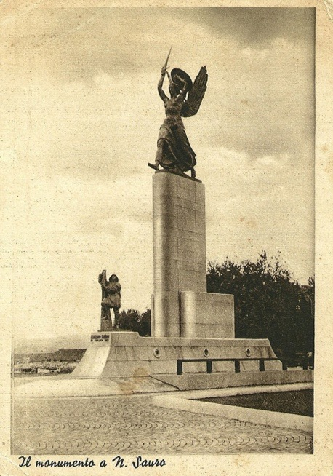
  - He wears his full uniform
  - Very huge; makes people feel small
- They increase the feeling of nationalism in the observer

Skills: digital skills, describe and deduct- Are there monuments dedicated to him? Why ?

This monument was inaugurated in 1935 (Capodistria)
The winged figure represents the victory and the redeemed Istria territory. In the forepart Sauro is presented as a helmsman. In the back Nazario Sauro's mother is presented refusing to acknowledge her son after his arrest in order to not betray him.
In 1945 the monument was demolished by the Slavs protected by the SS.

Filippo Corridoni’s biography

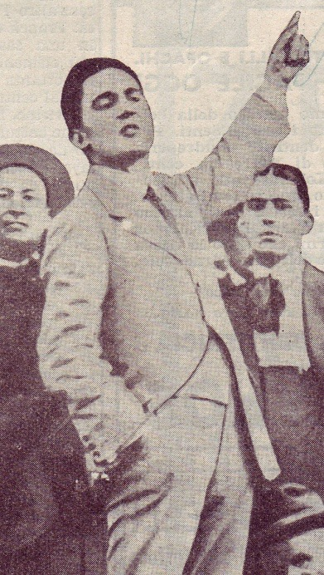
Filippo Corridoni was born in Pausula (Corridonia today in his honor) in the Province of Macerata, on August 19, 1887 and fell in combat on the Carso, the "Trench Frasche", October 23, 1915. He flowed immediately in the social unrest, militating in the ranks of the Revolutionary syndicalism. He thought that the workers' unions may create a state within a state and then proceeded to the conquest of power. He supported stoic firmness in a long series of battles against the employers who also led to persecutions and exiles. He combined the masses idea of revolution with the idea of ​​homeland and national duty; he sided with Mussolini for intervention. He also volunteered to be first line soldier.He often returned after difficult missions, repeating his usual phrase: "We must win at any cost. The enemy must be crushed."
On October 23, 1915 he moves to the assault of the Trench Frasche where he falls mortally wounded.He was decorated with a silver medal, which turned later into a gold medal at the memory.

3) Skills: analyze and interpret - Why people considered him a hero by using this biography ?
Filippo Corridoni, once dead, became a real myth. Mussolini used his image strongly and, so, his image became symbol of the right party. The fascist regime uses these heroic figures because it believes to be the heir of the war’s period.
Mussolini said, with rhetorical words, about him:

“Filippo Corridoni fu l'anima dell'interventismo popolare. Convinse, commosse, trascinò. Volle che alla sua predicazione seguisse l'azione, e ne partì volontario. Volle deliberatamente entrare in combattimento. Era in lui, mentre correva alla prima trincea austriaca sul Carso, una disperata volontà di immolazione, e quando la trincea fu espugnata, egli balzò in piedi sul parapetto gridando nell'oblio totale di se stesso: - Vittoria, Vittoria ! Viva l'Italia ! - E cadde fulminato nella morte dolce che non corrompe le carni, e non fa più soffrire...".

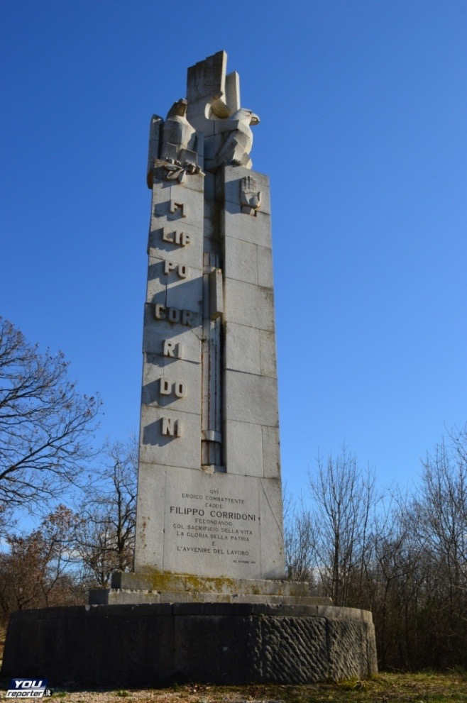
4) Skills: observe and describe - What do you see? ⁵
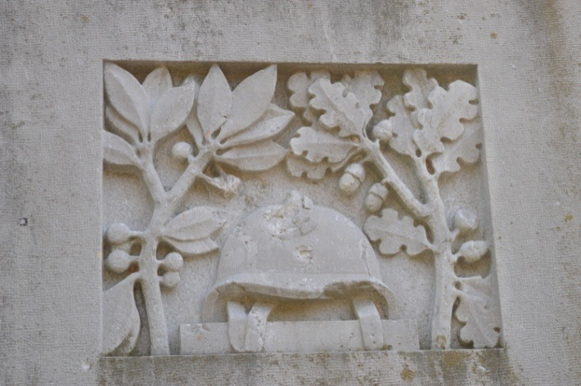

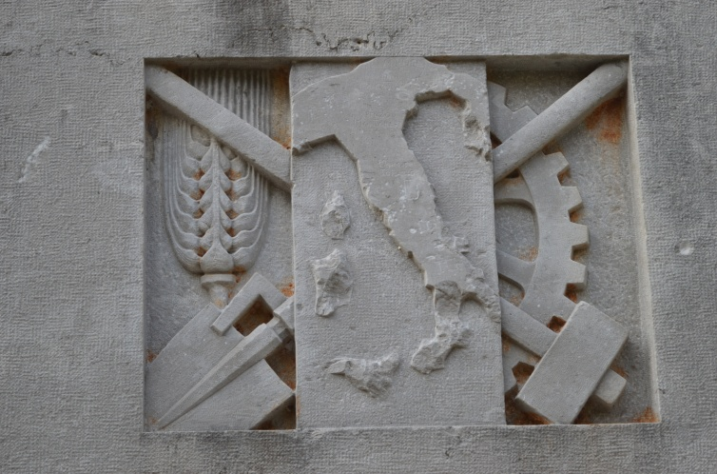

We see a tower in stone. At the bottom, it says: “Qui eroico combattente cadde Filippo Corridoni fecondando col sacrifico della vita la gloria della patria e l’avvenire del lavoro.”; it means “ Here, fell the heroic fighter Filippo Corridoni who has fecundated with his life’s sacrifice the glory of the country and the future of work”. Above we can see the blade and the fasces which are symbols of union, group, and it refers to ancient Rome. At the top, we can see the fascist salute and two eagles with a laurel branch. In the other images, we have in the first one the symbols of work, and in the second one a war helmet, a laurel and oak branches.

Skills: interpret and argue - With the previous answer and the biography of Corridoni, explain in what this memorial is fascist.
Corridoni was a part of the Italian Socialist Party, which refused the Italian upper middle class and thought that the war would repair that. At the time Mussolini, who was a soldier, regarded him as a prophet. The eagles are symbols of the power of Italy, and its reconstruction. About the other images, the first one represents the work.
And, especially, on the right, these are the laborers and on the left those are the farmers. Fascism wanted to put both together. It shows Corridoni like a syndicalist. In the other picture, it shows the sacrifice of the warrior because the laurel means peace and oak means strength and victory. Moreover, this tower is of a futuristic architecture, and the fascists liked that kind of architecture, because it meant the new technology.

Skills: deduct and decode - What are the functions of these monuments ?

The roles are to keep in mind that these people (Corridoni, Toti…) were important for the country and the nation, they have sacrificed their lives for the others. So, even after some decades we will be able to tribute and honor them, to keep in mind their bravery.

5) Skills: Synthesize and argue - What is a war hero? Explain by using the previous answers.

The war hero is generally the one who sacrifices him- or herself in battle for a greater good, for example in defense of the community, obtaining all honor and eternal memory, as well as huge glory and prestige to his descendants.
The act that makes a person a war hero can still be seen as a real obligation , as a duty prescribed to every respectable man in possession of virtues , so considering any deserter a coward.
In this context, it is expected that every respectable man is also ready for the most extreme sacrifice to defend his community , his country or his family.
The Great War was a test case for the patriotic spirit, waiting and hoping for the opportunity to complete the process of national unity, answering the call of irredentists who wanted that also Trento and Trieste would expose the tricolor flag on their windows. But it was also a terrible bloodbath. The price paid by Italy was of 650 000 dead, 947 000 wounded, 600 000 prisoners and missing. And tales of countless heroes, many of which remained unknown and escaped even the watchful eye of the newspapers that - for the first time - told on a daily basis what was happening on the first line of the front.

6) Skills: realize – Make a propaganda’s picture by using the previous answers.

http://www.centrostudibeppefenoglio.it/it/articolo/4-29-1146/personaggi/non-albesi-nella-toponomastica/toti-enrico
https://upload.wikimedia.org/wikipedia/commons/thumb/8/82/Beltrame_EnricoToti.jpg/220px-Beltrame_EnricoToti.jpg
³http://istriadalmaziacards.com/upload/cartoline/00000629/img114-01.jpg ⁶ http://biografieonline.it/img/bio/gallery/n/Nazario_Sauro_2.jpg
https://upload.wikimedia.org/wikipedia/it/8/83/Filippo_Corridoni_durante_un_comizio_interventista_a_Pavia.jpg 5Made by a professor

