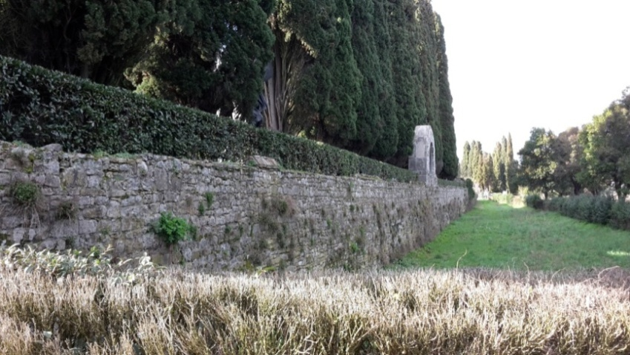
Heroes’ Cemetery
The Heroes’ Cemetery is located in Aquileia, seat of the and the main Roman cultural and political center and early Christian patriarchate, and surrounded by a medieval wall. In 1915, the first corpses of Italian soldiers who died on the Carso front were buried there. The cemetery has a symbolic function for Italian civilization. Aquileia is one of the most important places in the story of Friuli Venezia Giulia ,it was a colony and a Roman Port.

Compare this monument to things you’ve already seen.

What point of view does the monument provide?
It is sacrifizing the fallen soldiers and makes aware of the number of deaths WW1 caused.

Joffre trench
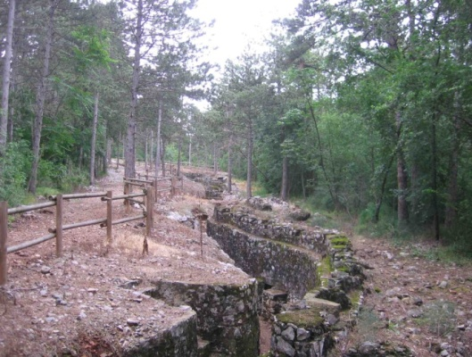
Joffre trench is a trench, built by the soldiers during the war to defend themselves from enemy fire. It is located on the east borders of Friuli Venezia Giulia, Italy, which was part of the Eastern Front.
Skills: Recover, find

-How do you imagine living in a trench for several months? How did the soldiers feel?

The ‘cave of the virgin’ and ‘bat cave’
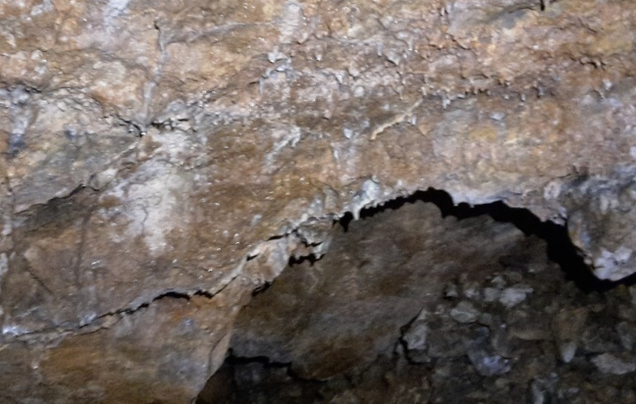
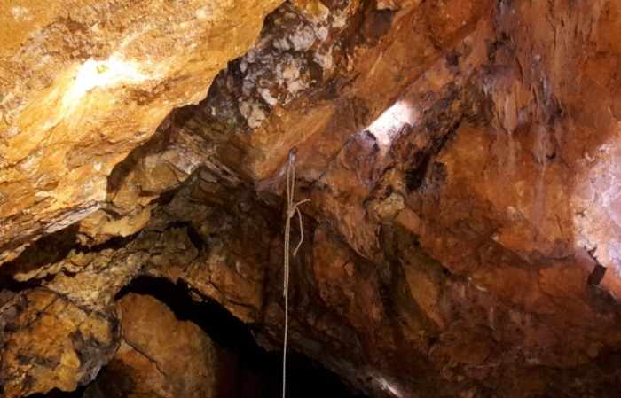

In the first picture we see the “Cave of the Virgin” , the second picture shows the “Bat Cave”. Both caves are located on the Monfalcone hills. They are typical examples of natural caves exploited for military use during WW1.
Skills: Recover, find

-What did the soldiers use them for?

The caves gave them shelter during e.g. a bomb attack.

-Think of positive and negative sides the caves might bring.

Ossario di Oslavia
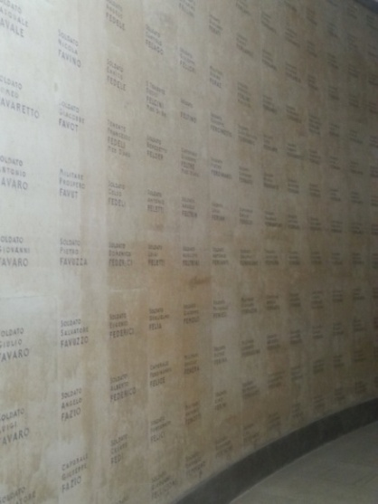

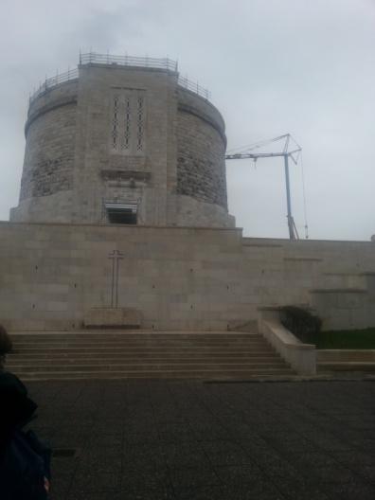

Ossario di Oslavia is a war memorial built in 1938, by Ghino Venturi. Inside the monumentum the names of 57.200 Italian and 539 Austro-Hungarian victims are written on the walls.
Skills: Realize or represent
- How does the monument represent the war?
It represents the tragedy of the war. It makes people aware of the large number of fallen soldiers.

Sacrario di Redipuglia
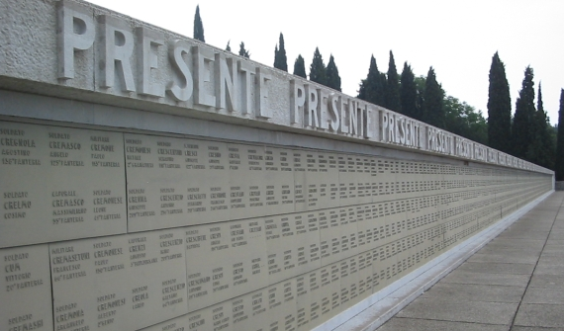
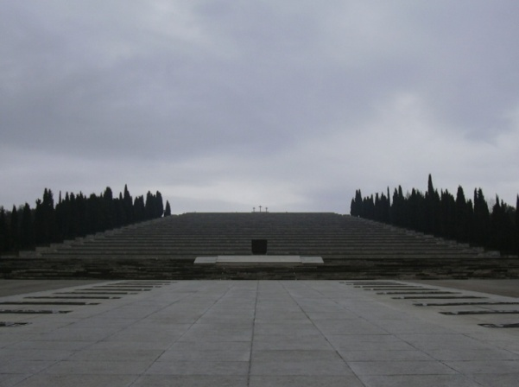

Sacrario di Redipuglia is a war memorial in Redipuglia, opened on 18. September 1938, preserving the remainings of 100.187 soldiers.
Skills: Deduct,decode
- What was the aim of building it?
It was biult to celebrate the sacrifice of the fallen soldiers.
Skills: Argue
- What feeling does it want to provide?
It is intended to make the visitor feel empathy with the soldiers fallen in WW1.
While walking it seems like the top of the monument is near, but in reality you get the feeling that you are walking the same way again and again, without a purpose. It is meant to recreate the soldiers` feelings during war.

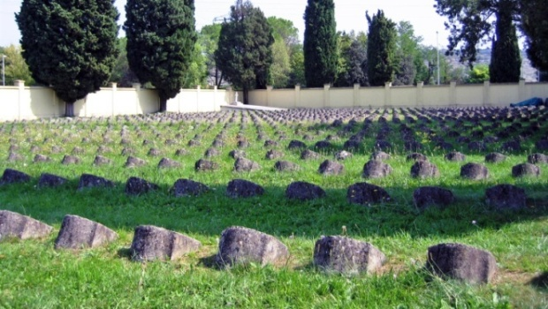
Austro-Hungarian Cemetery of Redipuglia

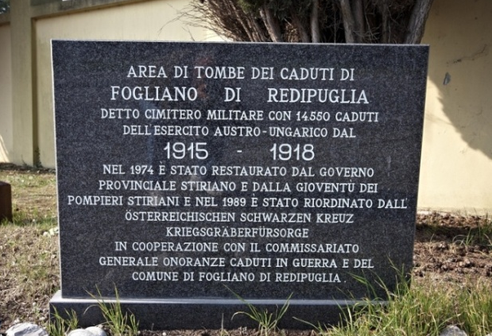
Austro-Hungarian Cemetery of Redipuglia is a monumentum representing the 14.550 soldiers fallen in this area.
The inscription in Italian recalls how this site was rebuilt by the provincial government of Styria and volunteers of the Young Styrian Firefighters in 1974. In the entrance you can see the words "Im Leben und im Tode vereint " in english “United in life and in death”.
Skills: Analyze and interpret
- What characterizes this cemetery?
Once inside it is possible to follow the long driveway bordered by cypress trees leading to the large grave. The rest of the cemetery has a lot of tombs of soldiers identified. Retracing the avenue toward the exit, next to the boundary wall , there are two other common graves of soldiers that are buried other devoid of generality.

Area Pacis Mundi of Medea
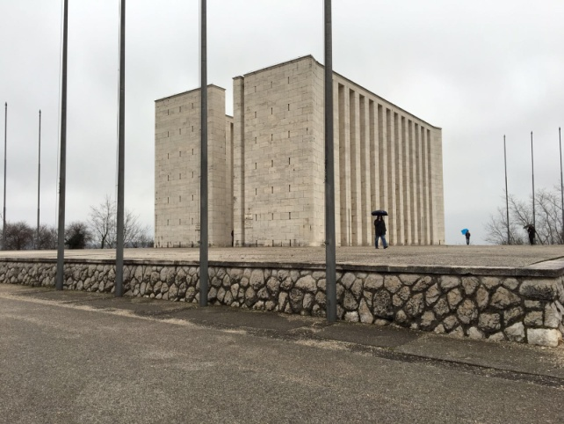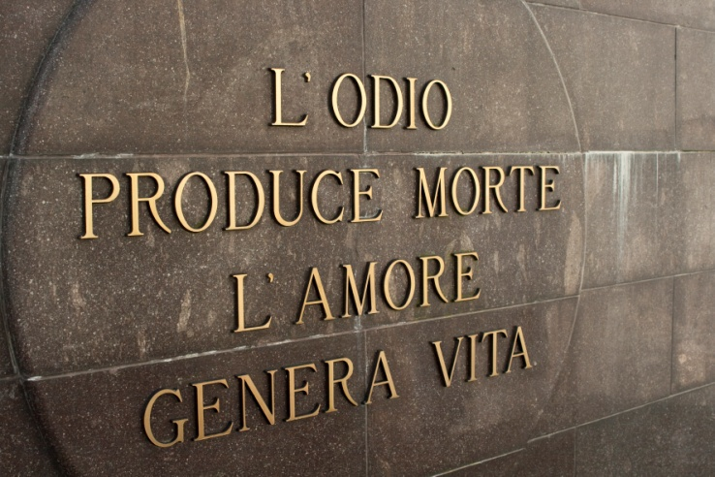
In the first picture one can see “Area Pacis Mundi of Medea”. It is a monumental complex in Medea, built in 1951. It is located on top of the Colle of Medea. It is 13 meters high and was built by Mario Bacciocchi. Inside one can find an urn saying “Hate causes death, love produce life”. The urn containing soil samples from all the battlefields around the world.

Skills: Analyze and interpret
- What is the architects’ aim of building this complex?
To symbolically remember fallen soldiers and warn about the war dramas.
Skills: Deduct and decode
- What point of view does it want to provide?
It shows the negative side of war. The monument reminds us of a prisons, which is meant to show that people are trapped in War. The quote empathizes that love should be the goal of all human beings.
FINAL QUESTION:
Skills: Synthesize
- What vision of the War does this project give us?
The project emphasizes the importance of peace and makes us aware of the terrible things that happened during the time of war. It wants us to keep in mind what happened a hundred years ago to prevent that things like that happen again.

