Celina, Wiesker, Marienschule Münster
- America
- U.S. government bonds
- Stereotypes of the enemy

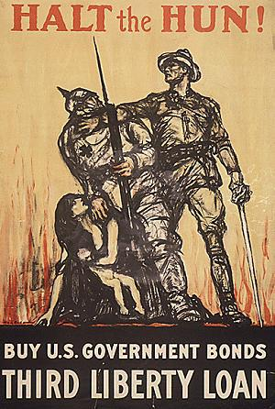
Halt the Hun!
The picture was published during the First World War as an advertisement for U.S. government bonds. It advertises the third war loan, which is called liberty loan on the poster.
On the picture, you can see four persons. A man fighting back another man who attacks a woman with her newborn baby. The man that attacks the woman and her baby is a Hun, which is in this case equal to a German. An American soldier stops the Hun. The two man are stereotypically presented.
The German or the Hun is shown with a spiked helmet (a characteristic of the Prussian soldiers), a bayonet and an iron cross (a typical symbol of the Prussian army). The Hun has his face covered and is bent over.
The American soldier stands straight and looks up; a superiority is created by his body language. He looks secure and confident, while he stops the Hun with only on arm and no weapons even though the Hun is armed. He does not wear a protection like a helmet for example.
The Hun wears protection, like his spiked helmet and is armed with a bayonet, but the American soldier fights him back easily.
The woman kneeling on the ground with baby is a religious image, representing the Virgin Mary and her son Jesus. Connecting this religious symbol with a war loan has a strong intention. This image of Mary and Jesus is called Pietà. When the Hun attacks the Pietà, he attacks the inner core of the family. Attacking something so private and intimate makes the Hun even more brutal and cruel.
In the background, you can see a city burning which the Hun probably already destroyed.
The Hun is presented as a cruel beast while the American saves his country with bare hands.
https://stahlgewitter.wordpress.com/category/aus-der-propaganda/
Tasks

- Discuss the picture rhetoric, using position, dimension and perspective as primary points of reference. (Analyse)
- Find out about archaic and symbolic elements of the picture. (Analyse and Interpret)
- Find out about the way in which Emperor Wilhelm II has previously referred to the Huns. (Recover, Synthesize)
- Discuss the above imperative and its message regarding its contemporary national, cultural and ideological background. (Synthesize)

